
This is an accessible version of the final report of a 6-month project (91250004) that started in October 2025, which was prepared by AHDB.
The work was funded by a contract for £33,999.88 from AHDB.
The original report can be requested from AHDB, which was prepared by:
- Julia Cooper and Catriona Willoughby, Organic Research Centre, RSK ADAS Ltd., Spring Lodge, 172 Chester Road, Helsby, Cheshire, WA6 0AR
- Fiona Fraser, SRUC Aberdeen, Craibstone Estate, Bucksburn, Aberdeen, AB21 9YA
- Paul Hargreaves, SRUC Barony, Parkgate, Dumfries, DG1 3NE

Author1, Author1 and Author2
1Address
2Address

Early indicators to monitor changes in soil health: evidence to update guidance for UK farmers
PR656

Any enquiries regarding this publication should be sent to us at:
AHDB, Siskin Parkway East, Middlemarch Business Park, Coventry CV3 4PE
Email: info@ahdb.org.uk
May 2026

Contents
Contents 2
Abstract 3
Acronyms 4
Introduction 5
Project structure 8
Materials and methods 9
Task 2.1 Delphi screening of potential early indicators to monitor change in soil health 9
Task 2.2 Evidence review of shortlisted indicators 10
Task 2.3 Stakeholder workshops 18
Task 3.1 Interpretation framework 19
Task 3.2 Knowledge gaps 19
Results 20
Task 2.1 Delphi screening– shortlist of indicators for further evidence review 21
Task 2.2 Critical evaluation of evidence 25
Stakeholder workshop outcomes 32
Discussion 40
Potential of shortlisted indicators to detect a change in soil health in 1-2 years 40
Limitations with biological indicators of soil function 44
Knowledge gaps and future research opportunities 45
References 47
Appendices 50
Results of first survey provided to Delphi respondents before completing the second survey 50
Delphi Survey – second round – conversion of ranked importance of criteria and ecosystem goods and services into weightings 53
Outline of final stakeholder workshops 55
Factsheet content 57

Abstract
The aim of this project was to update the guidance for AHDB levy payers on indicators of soil health, with a particular emphasis on those tests that can provide an early indication of a change in soil health following a recent change in management. Throughout the project indicators were evaluated based on their relationship to the following ecosystem services: Food, fibre and biomass production, soil carbon storage for climate mitigation, nutrient cycling i.e. provision of nitrogen (N), phosphorus (P) and potassium (K) to crops, and water regulation, including flood alleviation/runoff/erosion mitigation and drought mitigation. Criteria for evaluating indicators focused on indicator sensitivity to management change, link to changes in soil health, availability of robust, UK-relevant data, spatial variability and numbers of samples required to represent an area, cost to the client, and usefulness for farmers.
A long-list of ten indicators was identified at the proposal development stage based on recent expert reviews. These were: earthworms (adult count), CO₂ burst, potentially mineralisable nitrogen (PMN), crop rooting, soil carbon fractions, soil foodweb, phospholipid fatty acids (PLFA), enzyme assays, functional gene analysis and aggregate stability. A Delphi process was followed using an Industry Reference Group to reach a consensus on the top four indicators for an in-depth review of evidence which was compiled and scored using a logical sieve approach. Stakeholder workshops were held to sense-check the suitability of the indicators with end-users. Three indicators were identified for the development of updated guidance materials.
The top four indicators selected through the Delphi process were: PMN, crop rooting, active carbon (C) and aggregate stability. The industry experts recognised that PMN is a useful biological indicator reflecting the labile nitrogen pool; however interpretation of results is still limited. Crop rooting was viewed as an emerging and accessible farmer-led method that may offer good sensitivity to management but requires standardisation and development of interpretation frameworks. Active C was viewed as the carbon fraction most likely to respond to recent changes in management. Aggregate stability was strongly linked to soil physical health, particularly water regulating services. There was a clear consensus among the industry experts to exclude soil foodweb methods from further investigation due to the sometimes inconsistent and variable results and the lack of evidence indicating that these methods are sensitive to recent management changes.
Aggregate stability was the highest ranked indicator based on the evidence review, followed by crop root architecture, active carbon and potentially mineralisable nitrogen. Stakeholders provided valuable feedback during two workshops, emphasizing that farmer-led methods are preferred. The final shortlist of indicators for development of updated guidance were: aggregate stability including additional information on slake testing (an accessible, farmer-led technique), active carbon with a focus on permanganate oxidisable carbon and CO₂ burst as laboratory methods, and potentially mineralisable nitrogen. Crop rooting was excluded from further development since this method is still under development and only applicable to cereals in the UK. Updated “explainer” factsheets were prepared for knowledge exchange on the utility and value of using these tests as early indicators to monitor changes in soil health.

Acronyms
AI – artificial intelligence
AS – aggregate stability
DOI – digital object identifier
EGS – ecosystems goods and services
FAIR – findable, accessible, interoperable, reusable
HWEC – hot water extractable carbon
IRG – industry reference group
LOI – loss on ignition
MAOM – mineral associated organic matter
NAPESHM – North American Project to Evaluate Soil Health Measurements
PFLA – phospholipid fatty acids
PMN – potentially mineralisable nitrogen
POM – particulate organic matter
POXC – permanganate oxidisable carbon
qPCR – quantitative polymerase chain reaction
SHSc – Soil Health Scorecard
WSA – water stable aggregates

Introduction
Soil health can be defined as “the continued capacity of soil to function as a vital living ecosystem that sustains plants, animals and humans, and connects agricultural and soil science to policy, stakeholder needs and sustainable supply-chain management” (Lehmann et al., 2020). In the context of agricultural soils (both arable and grassland) key functions are normally listed as:
- Food, fibre and biomass production
- Soil carbon storage for climate mitigation
- Nutrient cycling i.e. provision of N, P & K to crops
- Water regulation, including flood alleviation/runoff/erosion mitigation and drought mitigation
Supporting biodiversity is sometimes also listed as a soil function.
Soil health is routinely monitored for two broad purposes:
- Governments and their agencies may monitor soil health to evaluate the impact of their policies on key outcomes. The new England Ecosystem Survey is an example of this type of monitoring. It includes measures of soil health that will be used to monitor the effects of policies, including those in the Sustainable Farming Incentive, that have been designed to promote good soil management. This type of soil health monitoring is normally conducted by trained surveyors according to a standardised set of protocols, using a stratified random sampling approach that aims to represent all land classes (habitats, land uses) (Emmett et al., 2024). Results will be anonymised and included in large databases for analysis by policy makers.
- Soil health can also be monitored by land managers at the farm-level to understand the capacity of their soils to deliver core functions and to help them to make decisions about future management practices. In this case the farmer or land manager may not share the results of their assessments with anyone. The primary purpose of this type of soil health monitoring is to learn about the effects of recent management on soil health and understand trends and patterns in soil health that may affect crop productivity and ultimately the farm’s long-term viability.
While serving two very different purposes, there is considerable overlap in the types of indicators used in both of these approaches to soil health monitoring. The focus of this project was on the latter, farm-level soil health monitoring.
There are already numerous soil health assessment frameworks in existence. For example, the Comprehensive Assessment of Soil Health (CASH) framework developed by Cornell University in the United States is designed to complement soil nutrient testing by providing guidance on evaluating physical and biological indicators that may highlight constraints to production and recommending mitigations to address these constraints (Moebius-Clune et al., 2016).
Here in the UK the AHDB provides advice on how to evaluate soil health through the Soil Health Scorecard (SHSc) which was launched in 2022 (AHDB, 2022). The existing scorecard includes a selection of physical (Visual Evaluation of Soil Structure or VESS), biological (earthworm counts, soil organic matter, microbial activity by potentially mineralisable N or CO₂ burst) and chemical (pH, extractable P, K and Mg) indicators of soil health. Most of the indicators within the scorecard are measured in laboratory from a soil sample, with VESS and earthworm counts measured in field.
Results for each test can be interpreted separately according to a traffic light system that indicates if the indicator value is acceptable (green) or requiring review/adequate (amber) or needs investigation/poor (red).
The SHSc is designed to provide a routine soil health check (every 3-5 years, ideally at the same point in a crop rotation) to identify areas where more focus or further detailed sampling may be needed. It supports farmers and agronomists when they are evaluating the effects of changes in farming systems or management practices in the medium term.
More recently, in part linked to the surge in interest in regenerative agriculture and a recognition of the importance of soil biological processes underpinning soil health, AHDB levy payers have been requesting updated information on indicators of soil health that provide an early indication of the impacts of soil management changes on soil functions. These early indicators to monitor changes in soil health should provide an indication of the magnitude and direction of change in soil health over a relatively short time period (1-2 years). The ideal indicator needs to be directly linked to key soil functions aligned with the list above, like nutrient supply, water cycle regulation, climate mitigation, and ultimately crop yield and resilience. And finally, an ideal indicator will be sufficiently sensitivity to react to recent changes in management, but not so sensitive that recent weather events or changes in crop species will affect the result.
Levy payer interest in early indicators of soil health resulted in an invitation to tender by the AHDB in 2025 to update guidance for UK farmers on “early indicators to monitor changes in soil health”. The overall goal was to improve levy-payer confidence in measuring and monitoring soil health, particularly focused on those indicators that are most suited to providing an early indication of a positive change in soil health.
This project was conceived in response to the above-mentioned tender. It was designed to rapidly evaluate the evidence for a selection of early indicators to monitor changes in soil health.
The tender requested that a preliminary list of possible indicators was provided at the bidding stage. The following indicators were proposed:
- Earthworms
Earthworms, which are currently part of the AHDB Soil Health Scorecard, were chosen due to their ease of measurement (for total counts) and some indications that they are sensitive to management, particularly tillage (Deeks & Rickson, 2023).
- CO₂ burst
CO₂ burst (Franzluebbers et al., 2000) is currently offered by soil testing labs in the UK as part of a soil health suite of measurements (e.g. Solvita CO₂ burst) and has been proposed as a proxy for soil nitrogen supply in the United States (Haney et al., 2001). It is also included on the current AHDB SHSc as an “optional” indicator of soil microbial activity.
- Potentially mineralisable nitrogen (PMN)
Potentially mineralisable nitrogen (PMN), another optional indicator of soil microbial activity on the current AHDB SHSc, was included on the list not only as a measure of microbial activity, but also as a property linked more directly to the nitrogen supplying capacity of the soil (Sharifi et al., 2007). PMN is provided by various soil testing laboratories in the UK using the anaerobic incubation method in which the N released from a soil sample immersed in water for 7 days (anaerobic) due to the breakdown of organic compounds (mineralisation) is measured (Keeney, 1982).

- Crop rooting
Crop rooting based on the “shovelomics” method proposed by Trachsel et al. (2011) and further developed and tested by ADAS in the Horizon Europe Root2Res project and by BOFIN in the TRUTH (Thriving Roots Underpinning Total soil Health) project, provides a direct indication of the conditions for crop growth in the field. It involves field excavation of mature root crowns followed by manual assessment of crop root architecture, angle and branching properties in field plants. Developed in field beans and also utilised in cereal crops, there are currently no protocols in place to assess grassland using shovelomics. The project team viewed it as a newly emerging method for soil health assessment, with potential as a low cost, farmer-implemented measure of soil health.
- Soil carbon fractions
Soil carbon fractions of unprotected (e.g. particulate organic matter or POM), mineral-protected (associated) organic matter (MAOM) (Rocci et al., 2024) and/or labile fractions such as permanganate oxidisable carbon (Lucas & Weil, 2012) and hot water extractable carbon (Ghani et al., 2003) were included as a group as an alternative to soil organic matter or total soil organic carbon which are currently part of the SHSc. There was a perception that some of these fractions (or pools) might be more sensitive to recent changes in management.
- Aggregate stability
Aggregate stability is a direct measure of soil health related to crop growth and water regulation in particular. Aggregates are formed as a result of the interaction of soil organisms with soil minerals and organic matter; fungi in particular are associated with the production of compounds (e.g. glomalin) that cement soil particles together into stable aggregates (Rillig, 2004). Aggregate stability can be measured in a laboratory by wet sieving (sometimes referred to as water stable aggregates) (Kemper & Rosenau, 1986) or slake testing (Collier et al., 2021), but there are also low-cost, farmer-led methods that provide an estimate of aggregate stability (e.g. the slake test that is part of the Soil Mentor app and the Slakes app). The Slakes app uses image analysis to quantify the disintegration of an air-dried aggregates when re-wetted and has been validated in various peer-reviewed studies (Fajardo et al., 2025; Flynn et al., 2020; Trybek et al., 2026).
- Soil foodweb approaches
Soil foodweb approaches to assessing soil biota (e.g. including active and total bacteria and fungi, and Fungal:Bacterial ratio) are currently attracting a lot of interest within the farming community. Various commercial laboratories offer these analyses using microscopy; some advisors and farmers are also training in the use of these techniques in home laboratories. The evidence linking these measures with soil health is limited (see Fierer et al., 2021) and the team felt it was important to include these methods in the project to provide improved guidance on their value.
- Phospholipid fatty acids (PLFA)
Phospholipid fatty acids (PLFA) provide information on total microbial biomass, as well as fungal, bacterial and faunal species groups (Ramsey et al., 2006). This method has been used by academics to characterise soil microbial communities for over 30 years (van Galen et al., 2025). Some commercial laboratories in the UK are exploring the potential of the method as an alternative, more robust approach to describing soil microbial communities than soil foodweb microscopy techniques.

- Enzyme assays
Enzyme assays e.g. β-glucosidase, N-acetyl-β-D-glucosaminidase, phosphatase and aryl sulfatase have been used for more than 40 years (van Galen et al., 2025) as measures of the potential of soils to perform specific functions, particularly those associated with the breakdown of organic compounds in the soil and release of plant nutrients (e.g. P by phosphatase). Recently an ISO standard (ISO 20130:2018) has been published for a high-throughput method for analysis of multiple enzymes using colorimetric substrates in micro-well plates (Cheviron et al., 2022).
- Functional gene analysis
Functional gene analysis using qPCR can be conducted as an alternative to the enzyme assays described above. Measures of nitrification (tracking ammonia monooxygenase genes) (Norton et al., 2002), proteolytic activity (Fuka et al., 2008), and nitrogen fixation (e.g. Orr et al., 2012) have been used to distinguish the effects of soil management on these soil processes. However, interpretation frameworks (e.g. for developing traffic light systems) do not exist.
The longlisted indicator list included several potentially promising biological indicators. Microbial community structure (the relative abundance of different species of bacteria and fungi) is thought to be relatively sensitive to management and methods to characterise microbial communities span microscopy, DNA-based methods, and fatty acid profiling. Two methods of assessing soil microbial community structure were thus included on the initial longlist: Soil foodweb and PLFA. However, while measures of microbial diversity and community structure provide an indication of the species present, they do not directly indicate the health of the soil in relation to key functions delivered by the soil microbial community. For this reason, two approaches to evaluating soil microbial functions were also included: enzyme assays and functional gene analysis.

Project structure
This project was split into four work packages and illustrated in Figure 1:
- WP1: Project Management
- WP2: Evaluation of Evidence
- WP3: Interpretation Framework
- WP4: Knowledge Exchange
Work package 2 was structured to robustly evaluate the evidence for each of the 10 indicators of soil health using:
- expert opinion (Task 2.1), building a consensus among a group of experts
- published evidence (Task 2.2), a synthesis of evidence from key references, including review of data availability and costs
- input from industry stakeholders on the top 4 indicators (Task 2.3), evidence presented and discussed in industry workshops
The AHDB was involved in discussions during each stage of WP2 and provided input on the final decision on the top three indicators after the industry workshops in Task 2.3. Outcomes were translated into interpretation materials (WP3) and findings disseminated (WP4). The outcome was a final list of indicators that are underpinned by solid scientific evidence that will be acceptable to the wider industry. Details of the methods followed in WP2 and WP3 are outlined below.
Figure 1. Diagram illustrating the project structure and steps followed to evaluate the indicators and arrive at the final shortlist of indicators for development of the interpretation materials
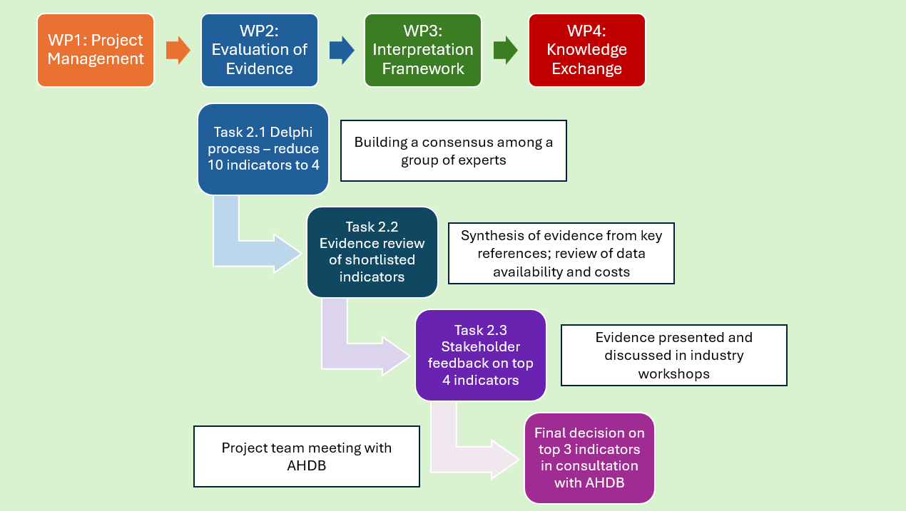

Materials and methods

Task 2.1 Delphi screening of potential early indicators to monitor change in soil health
A list of 10 possible early indicators to monitor changes in soil health were provided to the AHDB at the proposal stage as outlined in the Introduction. This list was screened using a Delphi approach to identify the top five indicators for more in-depth evidence review. Delphi is a recognised process used by social scientists to arrive at a consensus of expert opinion. The precise steps can vary, but it typically involves iterated questionnaires being presented anonymously to experts, with controlled feedback between rounds, and a final round of responses to produce a group consensus or judgement (Frewer et al., 2011). In this project the following steps were followed:
- An Industry Reference Group (IRG) was consulted and asked to comment on and prioritise the list of indicators in an iterative fashion. First, they completed an online survey with questions about the appropriateness of each indicator based on several criteria (e.g. strength of link to soil health, sensitivity, links to ecosystem service delivery).
- In line with standard Delphi methodology, respondents were then provided with a summary of the results of the first survey (see Appendix) and then resurveyed with some more probing questions on relative importance of the criteria for ranking indicators and links to ecosystem goods and services (EGS) from soils. Results were used to calculate weighted scores and ranks for each indicator. Weighting factors were calculated from the survey data as described in the Appendix.
- The final Delphi stage was to hold an online workshop with the IRG where the ranking of indicators with and without weightings as well as text and graphical representations of additional questions were presented. Participants were asked to first identify their top choices for three indicators to include in the final shortlist: these were the clear-cut or obvious choices (referred to in the workshop as “no brainers”). These were agreed following discussions as a whole group and in breakout rooms. Participants were then asked to consider the less obvious choices and choose two more indicators. These five indicators were discussed within the group in further detail, and a final, anonymous survey was conducted to achieve consensus. For each indicator, respondents were asked to vote either “yes” (to definitely include on the shortlist), “no” (to definitely exclude from the shortlist), or “unsure” (for indicators with uncertainty or insufficient information to decide). The threshold for inclusion of an indicator on the final shortlist was >70% of “yes” votes for the indicator.
In the second-round survey and during the industry workshop various comments were collected from the IRG. These were collated and synthesised using AI to provide some qualitative evidence of the expert opinion on each of the ten indicators. These are summarised in the results section of this report.
Based on the criteria above, consensus was reached for four of the indicators to be taken forward for in-depth evidence review as described in Task 2.2 Evidence review of shortlisted early indicators for soil health. For indicators where more than one method may be used to measure it, a “preferred” method and a “secondary” method were identified to assist with weighting outcomes of the evidence review (see Results for details).

Task 2.2 Evidence review of shortlisted indicators
A selection of “key references” was used as the basis for the evidence review. These were all recent reviews of evidence for soil health indicators and included extensive bibliographies which were mined to identify sources relevant to this project. This approach was chosen to avoid duplication of previous work reviewing the extensive academic literature on the subject of soil health and soil health indicator selection. References were chosen based on their consideration and reporting of six selection criteria, as well as whether they considered the relevant shortlisted soil health indicators. The six selection criteria were: sensitivity to management change, usefulness to farmers, analytical costs, spatial variability/sampling intensity, availability of UK data and delivery of ecosystem goods and services (Figure 2).
Figure 2. Visual summary of the six assessment criteria utilised in the evidence review
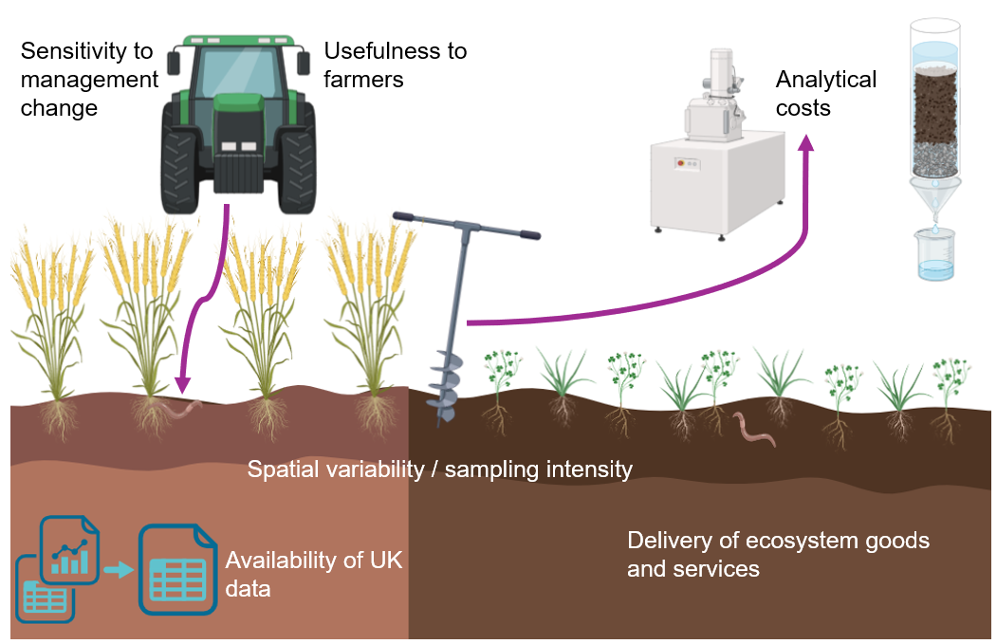
These key references were:
- Bünemann et al. 2018. Soil quality – a critical review. Soil Biology & Biochemistry, 120, 105-125.
- Deeks and Rickson. 2023. JNCC Report 737 Towards Indicators of Soil Health Annex 1: Review and evaluation of existing soil health indicators being used in the UK and internationally.
- Griffiths et al. 2018. Final Report No. 91140002-02 Soil Biology and Soil Health Partnership Project 2: Selecting methods to measure soil health and soil biology and the development of a soil health scorecard.
- Harris et al. 2025. JNCC Report 793, 25 Year Environment Plan Outcome Indicator E7: Healthy soils – proposed method for a soil health indicator for England.
- Rinot et al. 2019. Soil health assessment: A critical review of current methodologies and a proposed new approach. Science of the Total Environment, 648:1484-1491.
- Stott. 2019. Recommended Soil Health Indicators and Associated Laboratory Procedures. Soil Health Technical Note No. 450-03.

Scores for each indicator and each criterion were summarised using a logical sieve, a technique first developed by Black et al. (2008) and further refined by Ritz et al. (2009). The method is described by Deeks & Rickson (2023) as follows:
The conceptual framework, which the authors termed a ‘Logical Sieve’ (LS), was originally devised to provide an objective and quantitative means of ranking potential soil biological properties that are used as properties of soil quality / soil health. Run in an MS Excel based software tool, the Logical Sieve approach adopts a formalised method for assessing the relative strengths, weaknesses, and suitability of these candidate soil health measurements. The approach enables a consistent synthesis of available information and the semi-objective assessment of properties when tested against a series of scientific and technical criteria (known as ‘challenge criteria’).

Methods – Sensitivity to management change
The first key challenge criterion for the evaluation of shortlisted indicators was their sensitivity to management change. The results from the key references and their bibliographies were reviewed to select additional studies with titles related to soil indicators and management. The additional papers were accessed to check which indicator had been assessed, the methods, the key results and conclusions from the original source. The rubric used to compile scores aimed to summarise the strength and availability of the evidence in favour of each given indicator’s sensitivity to management change is shown in Table 1.
Table 1. Rubric used to score indicator sensitivity to management practice change utilised in the logical sieve.
Score | Summary | Description
3 | Strong evidence in favour | Review finds strong evidence in favour of indicator sensitivity derived from robust statistical analysis of replicated field experiments or through expert consultation
2 | Evidence in favour | Review finds some evidence in favour of indicator sensitivity through robust statistical analysis of replicated field experiments or through expert consultation
1 | Inconclusive evidence | Review reports mixed findings on indicator sensitivity
0 | Opposing evidence | Review finds no evidence or evidence to the contrary of indicator sensitivity
NA | Not considered | Review did not consider this indicator/category

Of all the key references, only Rinot et al, (2019) did not consider indicator sensitivity to management change, instead focusing on EGS provision. Each indicator was assessed and scored separately for its sensitivity to management practice change. Scores were averaged to give an overall indication of the findings from the academic literature in relation to each specified indicator and its sensitivity to management practice change. The resulting average scores for each indicator were then incorporated into the main logical sieve under the category “sensitivity”.

Methods – Link to delivery of EGS
The second key challenge criterion was delivery of ecosystem goods and services (EGS). The links between the shortlisted indicators and their capacity to detect early change in the delivery of EGS were determined through a rapid review of academic literature, commencing with the key references outlined in Section 4.2. Six EGS were specified for inclusion in the logical sieve: food, feed and fibre production; nutrient cycling (N); nutrient cycling (P and K); water regulation (flood prevention); water regulation (drought alleviation); climate change mitigation (carbon sequestration) (Figure 3).
The bibliographies of the key references were reviewed, and studies expected to cover at least one of the specified EGS and shortlisted indicators were selected. These papers were then accessed, and the indicators, associated EGS, methods, key results and conclusions were assessed. The rubric used to compile scores aimed to summarise the strength and availability of the evidence in favour of each given indicator’s capacity to indicate early change to the delivery of EGS is shown in Table 2.
Each indicator was assessed and scored separately for its capacity to detect changes in the delivery of each of the six EGS. This resulted in six sets of results to be incorporated into the logical sieve: one for each EGS. Indicator scores from each reference were averaged to give an overall indication of the findings from the academic literature in relation to each specified indicator and EGS. No weightings were used to determine the average at this point in the analysis, with each EGS weighted equally. The resulting average scores for each indicator and EGS were then incorporated into the main logical sieve.
Figure 3. A visual summary of the six ecosystem goods and services (EGS) which were included in the evidence review process.
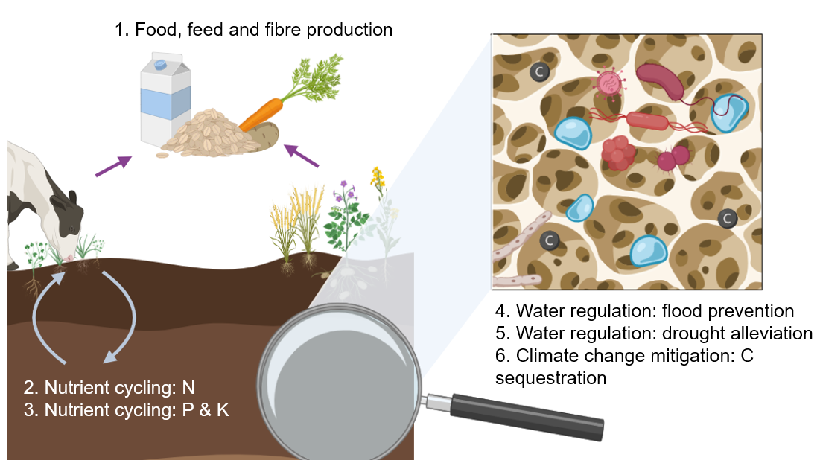
Table 2. Rubric used to score shortlisted indicators for their capacity to detect early changes in the delivery of ecosystem goods and services (EGS).
Score | Summary | Description
3 | Strong evidence in favour | Review finds strong evidence in favour of indicator relevance to overall soil health derived from robust statistical analysis of replicated field experiments or through expert consultation
2 | Evidence in favour | Review finds some evidence in favour of indicator relevance to overall soil health derived from robust statistical analysis of replicated field experiments or through expert consultation
1 | Inconclusive evidence | Review reports mixed or inconclusive findings on indicator relevance to overall soil health
0 | None/opposing evidence | Review finds no evidence or evidence to the contrary of indicator relevance to overall soil health
NA | Not considered | Review did not consider this indicator/category

Methods - Data availability
A key criterion for evaluation of the indicators was the availability of data that was robust, independent and relevant to UK agriculture. A range of data sources were identified using online search engines, known open-access repositories, discussions with industry representatives (including laboratories who were part of the IRG), and contacts with key informants. For open-access datasets, the time period from 2016 forwards, which corresponds with the introduction of FAIR data principles and strengthened data-sharing requirements, was the focus.
- The bibliographies of the key references were reviewed, and studies selected which were expected to cover the shortlisted indicators. Data availability statements of each paper were checked, with DOIs followed to repositories, and the licence and metadata quality was directly assessed. Information on the indicators including size of the datasets, type of study, and geographic location of the study was recorded.
- The re3data.org website was used to search for online repositories of data using the search term “soil”. This returned 77 results. These were screened manually for repositories relevant to soil health; many of these sites were not relevant as they contained information relating to soil classification. Relevant sources of soil health data included: European Soil Data Centre (ESDAC), Zenodo, BonaRes, AgDataCommons, Rothamsted Long-term Experiments Electronic Archive. These repositories were searched for studies on soil health or our specific indicators and descriptive information was recorded as listed above.
- One particularly interesting, source, which was a metadata catalogue of 688 European, national and European Joint Programme (EJP) Soil project datasets was identified. The file contained titles, keywords and abstracts. The records that included shortlisted indicators were tagged for further evaluation.
- Alongside the review of data sources described above, the Industry Reference Group was also contacted to identify potential sources of data for developing the interpretation framework.
The outcome of this exercise was a spreadsheet listing datasets and descriptive information. This was used to underpin the scoring system shown in Table 3 applied to each of the indicators (PMN, POXC, HWEC, aggregate stability, slake testing, shovelomics/crop rooting).
Table 3. Rubric used to score each indicator on the basis of key criteria relevant to data availability
Criterion | Good availability of data (2) | Moderate availability of data (1) | Poor availability of data (0)
Volume of data | Multiple (>5) datasets with at least 100 entries are available | Some (1-5) datasets with at least 100 entries are available | No datasets with at least 100 entries are available
Geographic relevance of the data | >50% datasets from a UK source | >50% datasets from a temperate climate zone outside UK | Data is not from a UK-relevant region
Relationship to soil health indicator | >50% of the data is for the same soil health indicator measured using the preferred method | >50% of the data is for an indicator of the same process/ function, but not the specified method | NA
Robustness of data | >50% of data from national monitoring schemes or research projects representing a broad range of soil types and management | >50% of data is from a specific experiment with limited range of soil types or management or meta-analyses | NA

Scores for each of the four criteria in the rubric were averaged for each indicator and added to the main logical sieve. Where more than one method was used to generate the data, scores for the preferred method were weighted more heavily when calculating the averages.

Methods – Usefulness for farmers
The utility of any shortlisted indicator to farmers was particularly important to ensure that proposed indicators were positively received in the farming community. To this end, stakeholder workshops (two, online) were held where all shortlisted indicators were presented to farmers and advisors, alongside briefings which described each indicator method, meaning and potential on-farm application (see Task 2.3 Stakeholder workshops).
Participants were then asked to vote on whether or not they would want to include each indicator in their on-farm soil health assessments. The votes were incorporated into the logical sieve using a scoring rubric based on the results from both industry workshops (Table 4).

Table 4. Rubric used to score the farmer utility of the indicator shortlist.
Score | Summary | Description
2 | Easily interpretable by farmers | Results show that the majority (over 60%) of participants know enough about this indicator to include
1 | Somewhat interpretable by farmers | Results show that some participants know enough about this indicator to include
0 | Currently uninterpretable by farmers | Results show that majority of participants do not know enough about this indicator

Methods – Spatial variability/sampling intensity
Spatial variability and sampling intensity for each of the commercially available indicators was determined through a review of recommended number of samples required to give a representative field area from key UK laboratories or in the case of slake testing, from app protocols (Metric 1). These were:
- NRM – Part of Cawood Scientific, NRM hosts the UK's largest agricultural soil testing facility, which states that it analyses over 450,000 soil samples every year (https://cawood.co.uk/nrm/soil-analysis-nrm/).
- Yara – Trading as Lancrop Laboratories, Yara works across agricultural, horticultural, environmental and amenity sectors and reports that it performs over two million analyses annually on samples received worldwide, including the UK (https://www.yara.co.uk/crop-nutrition/farmers-toolbox/analytical-services/soil-testing-and-analysis/).
- Hill Court Research – In operation since 2003, Hill Court Research offers a range of agricultural analytical tests, including many soil nitrogen related analyses (https://hillcourtresearch.co.uk/soil-testing-and-analysis/).
- Eurofins – Consisting of a network of agricultural laboratories worldwide, Eurofins Agro focusses on soil, crop, water, compost and manure analysis, with the headquarters located in Wageningen (https://www.eurofins-agro.com/en/soil-health-solutions).

Because not all shortlisted indicators were commercially available, it was not possible to assess the entire shortlist via Metric 1. Therefore the expert opinion in the project team was utilised to determine spatial sensitivity of the complete indicator shortlist (Metric 2). As shovelomics is currently only commercially available from ADAS, the spatial requirement was determined via expert consultation with Pete Berry, Charlotte White and Christina Baxter, ADAS Crop Physiology. The scoring rubric combined outcomes from both metrics (Table 5).
Each score was averaged across metrics 1 and 2 for each indicator to give an overall score which incorporated both sampling requirements and anticipated spatial variability. Average scores were then incorporated into the main logical sieve.
Table 5. Rubric used to score each indicator and method in terms of spatial variability. Table ‘a’ shows scores based on commercial protocol and Table ‘b’ shows scores based on expert opinion.
- Commercial protocol (Metric 1)
Score | Summary | Description
2 | Few samples needed | 1 - 5 samples per field recommended
1 | Standard samples needed | 5 - 20 samples per field recommended
0 | Many samples needed | >20 samples per field recommended
- Expert opinion (Metric 2)
Score | Summary | Description
2 | Low expected spatial variability | Property measured in a lab and a composite sample from the field representative of a management unit is recommended.
1 | Medium expected spatial variability | Property measured in situ and may require several measures in the field; not likely to be highly spatially variable (5-20 samples/field)
0 | High expected spatial variability | Property measured in the field and expected to be highly spatially variable. (>20 samples per field)

Methods – Analytical costs
To investigate the analytical costs of each of the shortlisted indicators, the availability and costs of testing from the four main commercial laboratories offering soil health related testing in the UK (outlined above) was reviewed. These four providers were used to assess the more “traditional” analytical tests in our shortlist – namely active carbon (POXC), potentially mineralisable nitrogen, and water stable aggregates (determined via wet sieving). The cost categories used were in line with the price of the current most popularly used agricultural soil tests, with £10 being equivalent to an SOM test at a commercial laboratory, while £10 - £30 being equivalent to pH, P, K, and/or Mg testing per sample.
Crop rooting via shovelomics is currently only commercially available via ADAS, thus an internal consultation was carried out with the ADAS Crop Physiology team, who provided an indicative quotation for costs of a single assessment (£65), costs of running a practical workshop to teach others how to assess shovelomics in the field (~£1400), as well as signposting to work conducted in collaboration with the British On Farm Innovation Network (BOFIN), in which the necessary materials for conducting the assessments were published freely online. Finally, slake testing was considered due to considerable farmer interest in soil health tests which can be conducted on farm. Two available apps for conducting slake tests were investigated: Soilmentor, which has a monthly subscription of £35 in the UK for up to 8 fields, and SLAKES, which is freely available and has recently been trialled in the AI4SoilHealth project with promising results. All of the information gathered was used to score each indicator and analytical method in terms of associated costs to the user (Table 6).
Table 6. Rubric used to score each indicator on the basis of associated analytical costs.
Score | Summary | Description
2 | Low cost per sample | Commercial laboratories charge < £10 for a sample to be analysed for this indicator; instructions necessary to assess this indicator are freely available online
1 | Medium cost per sample | Commercial laboratories charge £10 - £30 for a sample to be analysed for this indicator; instructions necessary to assess this indicator are available online for a fee of <£30
0 | High cost per sample/ not commercially available | Commercial laboratories charge > £30 for a sample to be analysed for this indicator; instructions necessary to assess this indicator are available online for a fee of >£30

Each methodology (as opposed to indicator) was assessed and scored separately for its associated analytical costs, to best account for the differences in availability and cost between laboratory, app and field-based assessments. The resulting average scores for each method were then incorporated into the main logical sieve under the category “costs”.

Task 2.3 Stakeholder workshops
The final stage of the evidence review was to conduct two stakeholder workshops for collecting feedback on the results of the evidence evaluation and final shortlisting (target of three indicators) for development of further guidance and interpretation frameworks. Two online workshops were held on 10 February 2026 using the Zoom online video conferencing platform. The workshop programme for both a morning and afternoon session was identical. The workshops were advertised through the normal channels (social media posts, ORC ebulletin, AHDB newsletters) and the target audience was farmers and advisors who routinely use soil health testing. Participants registered through Eventbrite and filled in a questionnaire indicating their background and interest in soil health testing; individuals who did not meet the target audience criteria were informed that they could not attend. A video of the main workshop content was released on YouTube after the event to ensure that access to the findings from the evidence review were openly available. It is available to view here.
The programme was designed to maximise the opportunity for feedback from participants and peer-to-peer interactions and the online survey tool Menti was used to collect anonymised responses to key questions (see Appendix: Outline of final stakeholder workshops). Breakout rooms were used to promote peer-to-peer interactions with comments recorded on the anonymised whiteboard tool Padlet. Responses from the Menti, Padlet whiteboards and the Zoom chat were compiled and analysed using AI to provide a comprehensive assessment of stakeholder attitudes towards the indicators reviewed in the project. The final Menti survey followed the same format as the Delphi process with respondents asked to vote to include, exclude or not enough information, for each of the indicators presented. Outcomes of the stakeholder voting were presented to the AHDB team for direction on the best approach for development of further guidance and interpretation frameworks for the top-scoring indicators.

Task 3.1 Interpretation framework
In the original proposal the intention was to “to produce an early indicators of soil health scorecard with a similar format to the current version, but with an interpretation of what scale and rate of change in each metric is meaningful …for the top 3 ranked indicators resulting from task 2.3.”
Following the feedback from stakeholders (see Results section: Stakeholder workshop outcomes) it was recognised that there was more background work to be done on explaining the utility of the shortlisted indicators; data limitations that would affect the potential to design traffic lights for each indicator were also identified. A project update meeting was held with AHDB to ensure alignment of final project outputs with funder expectations. On this basis, it was agreed to focus on “explainer factsheets” for each shortlisted indicator (see Appendix). For PMN only, a more in-depth analysis of existing datasets was proposed to update current thresholds which are based on statistical analysis of 625 samples as part of the original Soil Biology and Soil Health Partnership project (see Bhogal et al. 2020).

Task 3.2 Knowledge gaps
Throughout the project knowledge gaps were highlighted and compiled by the project team. This included: during the expert Delphi process (see qualitative analysis of results), during the evidence review, particularly flagging gaps identified in the key resources, and during the stakeholder workshops. These gaps were synthesised and reviewed by the team.

Results
A visual summary of the results of each stage of the indicator evaluation process is provided in Figure 4. In Task 2.1 the IRG was asked to prioritise and rank the ten indicators and selected PMN, crop rooting, active C and aggregate stability to take forward. At this stage of the process, methods for each indicator were not defined; however, to conduct the evidence review in Task 2.2, it was necessary to clearly specify the method to accurately evaluate the evidence. In some cases (e.g. active C and aggregate stability) there is more than one recognised method (see Introduction for more detail and citations on each method). POXC was more commonly reported in the evidence and was the preferred method for measuring active C. Wet sieving was the preferred method for measurement of aggregate stability. The method used for measuring potentially mineralisable nitrogen was anaerobic incubation. In Task 2.3 stakeholders strongly favoured farmer-led assessments including slake testing and shovelomics. Following consultation with AHDB the final decision on the top 3 indicators was to update guidance on aggregate stability, active C (POXC) and PMN.
Figure 4. Summary of results for each stage of the evaluation process with outcomes shown in white boxes next to each task.
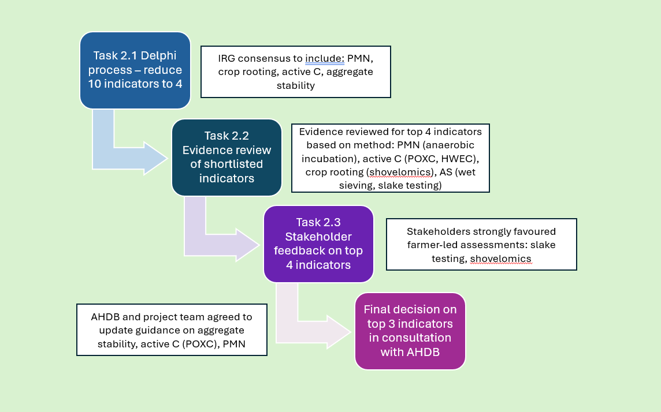

Task 2.1 Delphi screening– shortlist of indicators for further evidence review
The outcome of the first-round survey of experts is shown in the summary report (see Appendix). At this stage earthworms ranked highest followed by potentially mineralisable nitrogen (PMN), crop rooting and CO₂ burst. Measures of microbial diversity and function (PLFA, enzyme assays, soil foodweb and qPCR) were ranked the lowest.
In the second survey after being presented with outcomes of the first-round, experts ranked the indicators differently (Figure 5). Water stable aggregates moved into the top ranked spot. The order of the remaining indicators stayed similar to the first-round with three of the four measures of microbial diversity and function ranking lowest.
Figure 5. Expert ranking of 10 early indicators of soil health in the second-round survey.
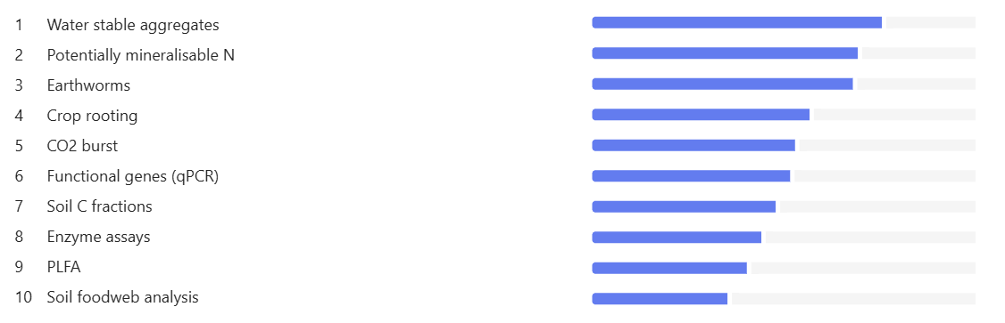
Figure 5 shows a ranked list of 10 soil health indicators on the left, with horizontal bars on the right representing their relative importance based on expert scoring.
Indicators are listed from highest to lowest ranking:
- Water stable aggregates (longest bar – highest ranked).
- Potentially mineralisable nitrogen.
- Earthworms.
- Crop rooting.
- CO₂ burst.
- Functional genes (qPCR).
- Soil carbon fractions.
- Enzyme assays.
- PLFA.
- Soil food web analysis (shortest bar – lowest ranked).
The bars decrease in length from top to bottom, showing a gradual decline in ranking scores.
Overall pattern:
Physical and biological indicators such as aggregate stability, nitrogen availability, and earthworms are ranked highest.
More complex or laboratory-based measures, such as PLFA and soil food web analysis, are ranked lower.

The comments collected from both the surveys and compiled from the workshop discussions were summarised using AI to provide a representation of expert opinion on each of the indicators (Table 7). This provides useful explanatory information about the reasons for the final ranks. Soil carbon fractions and specifically those representing “active C” (POXC, HWEC) were considered the most promising because they were considered sensitive to management and relatively easy to measure (in a laboratory). Earthworms were also considered very useful indicators but were excluded from the final list for reasons outlined below. Crop rooting/shovelomics could be conducted by farmers and was perceived to have a strong link to soil physical conditions and related functions.
Aggregate stability was also strongly linked to functions, although concerns about accessibility of laboratory testing and reliability of farmer-led (e.g. slake tests) assessments were raised. The comments on PMN were moderately positive, with some concerns about a weak link to functions and the need to provide more refined thresholds for interpretation.

Table 7. Synthesis of comments from the Industry Reference Group from both surveys and the workshop, on each of the 10 long-listed indicators during the Delphi process. Comments summarised and ranked in order from most positive to least positive, using AI.
Indicator | Synthesis of text comments
Soil C fractions | Soil carbon fractions (e.g. POXC, HWEC) are considered sensitive to management and relatively easy to measure, making them strong candidates as early indicators. They reflect active carbon pools linked to microbial activity, though may not represent long-term carbon storage. Interpretation remains a challenge, particularly in linking results to soil function. Some fractionation methods are complex and expensive, but overall, this is seen as one of the most promising and responsive indicator groups.
Earthworms | Earthworms are a simple, farmer-friendly indicator already included in existing soil health scorecards. They can be linked to soil functions such as structure and nutrient cycling, but responses may lag behind management changes. Their usefulness varies with soil type (e.g. less reliable in sandy soils), and there is a need to refine thresholds and interpretation. Despite limitations, they remain a practical and accessible indicator.
Crop rooting/ shovelomics | Crop rooting provides a direct, field-based indication of soil physical condition and function, using the crop as an integrator of soil processes. It is practical and relevant to farmers but requires training for consistent assessment. It is considered a useful indicator of soil structure, porosity and water relations, and may offer good sensitivity to management, although standardisation and interpretation frameworks need development.
Aggregate stability | Aggregate stability (particularly water-stable aggregates) is strongly linked to soil physical function, including water infiltration, erosion resistance and porosity. It is conceptually robust and functionally relevant, but there is some ambiguity between laboratory methods and simpler field tests (e.g. slake test). Laboratory approaches are more reliable but less accessible. Overall, it is considered a meaningful indicator of soil physical health.
Enzyme assays | Enzyme assays are well-established with a strong literature base and may act as leading indicators of soil biological activity and nutrient cycling. They are relatively practical and recent advances have improved throughput. However, interpretation remains a key limitation, with results highly dependent on soil type and climate, requiring locally derived reference values. Further research is needed to link enzyme activity more clearly to soil function and to develop robust interpretation frameworks.
Potentially mineralisable nitrogen (PMN) | Potentially mineralisable nitrogen (PMN) is a useful biological indicator reflecting the labile nitrogen pool, but interpretation is currently limited. Existing thresholds are broad and largely based on average datasets rather than functional outcomes. It requires incubation (typically one week), reducing practicality. While useful as an indicator of nitrogen supply potential, it is not yet well linked to timing of nutrient release or wider soil functions.
CO₂ burst | CO₂ burst testing provides an indication of microbial activity, but its relationship to soil health is unclear and may require further research. It overlaps conceptually with active carbon measures but does not necessarily provide distinct or well-interpreted information. While simple to perform, its relevance as an indicator of soil function is uncertain, and clearer interpretation frameworks are needed.
Soil foodweb | Soil food web analysis has gained interest, particularly in regenerative farming, but concerns exist around reliability and interpretation. Results can be inconsistent or misleading (e.g. unexpected absence of fungi), and the method requires microscopy, limiting practicality. There is currently insufficient evidence of sensitivity to management changes. Further research and larger datasets are needed to assess its effectiveness and improve confidence in its use.
Phospholipid fatty acids (PLFA) | PLFA is a long-established method that provides information on microbial community structure (e.g. fungi:bacteria), but generates complex datasets that are difficult to interpret. While indicative “good” and “bad” ranges exist, there is limited understanding of how detailed outputs relate to soil function. The method is relatively expensive and lacks a strong interpretation framework, which limits its practical application despite its scientific value.
Functional gene analysis using qPCR | DNA-based methods provide detailed information on microbial abundance and functional genes, but interpretation remains a major challenge. Results can be affected by soil chemistry and include DNA from non-living organisms, complicating interpretation. While promising, especially for nutrient cycling pathways, these approaches generate large datasets that currently lack clear links to soil function or actionable thresholds. Further research is needed to understand how microbial composition relates to soil health.

The outcomes of the final vote to include or exclude each indicator on the final shortlist are shown in Table 8. PMN, crop rooting, aggregate stability and active carbon all had more than 70% approval for inclusion in the next phase of the evidence review. Soil foodweb analysis was clearly excluded from the next phase. No consensus was reached on PLFA and enzyme assays. It should also be noted that CO₂ burst, qPCR and earthworms were not included in the final vote. While earthworms had scored highly in the first and second-round surveys, the AHDB preferred that resources were directed to less well-established existing indicators of soil health. There was also a recognition among the IRG that total earthworm counts are a crude measure of soil health; a more refined measure would require expertise in earthworm species identification, which is rare.
Table 8. Summary of the outcomes of the Delphi process for shortlisting of indicators by the Industry Reference Group
Indicator | Consensus decision | Consensus proportion (%)
PMN | Include | 100
Crop Rooting | Include | 87.5
Active C | Include | 75
Aggregate Stability | Include | 75
Soil Foodweb | Exclude | 75
PLFA | No consensus reached (exclude/unsure) | 12.5/50
Enzyme Assays | No consensus reached (exclude/unsure) | 50/12.5

Task 2.2 Critical evaluation of evidence

Sensitivity to management change
From the sources reviewed, an average score for indicator sensitivity to management change was calculated (Table 9). It was not possible to differentiate between the two methods for the analysis of Active C, based on the details provided in the reviewed sources, thus both were given the same score for this category. The indicator which scored the highest for sensitivity to management change was crop rooting, as determined through Shovelomics (average score of 2.0). This was followed by aggregate stability through assessment of water stable aggregates (average score of 1.5). Slake testing had the lowest score, which was largely due to papers in which it was included having low confidence in its sensitivity due to a lack of available data on this indicator (Table 9).

Table 9. Average scores for each indicator for the "sensitivity to management" criterion
Indicator | Method | Overall score
PMN | 7-day anaerobic incubation | 1.20
Active C | Potassium permanganate extraction | 1.33
Active C | Hot water extraction | 1.33
Crop Root Architecture | Shovelomics | 2.00
Aggregate Stability | Water stable aggregates (wet sieving) | 1.50
Aggregate Stability | Slake test | 0.67

Changes in indicator indicate a change in soil health/positive impact on EGS delivery
From the sources reviewed, an average score for indicator capacity to detect early changes to each of the six specified soil related EGS was calculated (Table 10). It was not possible to differentiate between the two methods for the analysis of Active C, based on the details provided in the reviewed sources, so an overall score is given for the metric as opposed to differentiating between the specified methods. The indicator which scored the highest for potential to monitor provision of soil related EGS was wet sieved water stable aggregates, followed closely by active carbon (Table 10). The indicator which was found to have the lowest score for links to provisioning of soil-related EGS was PMN – this was driven by lower scores in water regulation and nutrient supply - P&K categories, compared to strong scores in the food production and N provisioning categories (Table 10).

Table 10. Average scores obtained for each indicator and method for potential to monitor provisioning of soil health related EGS
Indicator | Method | Food, biomass and fibre | Nutrient cycling – provision of N | Nutrient cycling – provision of P&K | Water regulation - flood prevention | Water regulation - drought alleviation | Climate mitigation through C sequestration | Overall soil EGS Score
PMN | 7-day anaerobic incubation | 2.40 | 1.8 | 0.40 | 0.33 | 0.33 | 0.67 | 5.93
Active C | Potassium permanganate extraction | 2.00 | 1 | 1.40 | 1.67 | 1.5 | 1.67 | 9.24
Crop Root Architecture | Shovelomics | 2.33 | 1 | 1.00 | 1.00 | 1.00 | 0.60 | 6.93
Aggregate Stability | Wet sieving | 2.67 | 2.2 | 2.2 | 1.5 | 1.33 | 1.33 | 11.33

Availability of robust UK relevant data
The data repositories described in ‘Methods - Data availability’ were reviewed. Some potentially useful datasets were identified. The 2007 England Countryside Survey data is freely available and includes aggregate stability, particle size distribution and land use information from 419 sample locations. In Europe the LUCAS 2018 dataset on soil function includes 885 measurements of water stable aggregates linked to a variety of measures of soil biological function and diversity. A search on “soil health” in the AgDataCommons, which is the USDA’s online repository powered by FigShare, returned 57 results. This included a comprehensive dataset (489 records) from the Dynamic Soil Properties for Soil Health (DSP4SH) initiative that covers various measures of aggregate stability and active C with useful additional information on management and soil characteristics. The AgDataCommons search also identified a large dataset (1453 records) published by the US-based Soil Health Institute (North American Project to Evaluate Soil Health Measurements, or NAPESHM), covering PMN, active carbon, slake testing and aggregate stability.
The details on numbers of datasets identified and scoring of each indicator based on data availability are shown in Table 11. It is notable that there were no publicly available datasets identified for shovelomics and datasets for crop rooting in general were limited. The indicators with the highest scores for availability of data were potentially mineralisable nitrogen and active carbon; but these scores were skewed due to the large volumes of data collected by commercial laboratories for these indicators. Other important indicators (e.g. aggregate stability) are not offered by commercial laboratories; nonetheless a total of 20 experimental datasets linked to aggregate stability were identified dominated by studies using wet sieving methods (“other” in Table 11) and representing a useful resource for development of interpretation frameworks.

Table 11. Average scores for the availability of robust UK relevant data criterion; details of scoring system are explained in ‘Methods - Data availability’. NA = not applicable. Overall scores followed by an asterisk were used in the logical sieve for each indicator.
Indicator | Number of datasets identified | Volume of data | Geographic relevance | Relationship to soil health indicator | Robustness of data | Industry data supply | Overall score (average of each data criteria)
Potentially mineralisable N | 4 | 1 | 1 | 2 | 1 | 2 | 1.4*
Active C (Potassium permanganate) | 9 | 2 | 1 | 1 | 1 | 1 | 1.2
Active C - other | 6 | 2 | 1 | 1 | 1 | N/A | 1.25
Active C overall | N/A | N/A | N/A | N/A | N/A | 1 | 1.22*
Crop root architecture - Shovelomics | 0 | 0 | N/A | 1 | N/A | N/A | 0
Crop root architecture - other | 2 | 0 | 1 | 1 | 1 | N/A | 0.75
Crop rooting overall | N/A | N/A | N/A | N/A | N/A | N/A | 0.3*
Aggregate stability - WSA | 5 | 1 | 1 | 1 | 1 | N/A | 1
Aggregate stability - Slake test | 2 | 1 | 1 | 1 | 0 | N/A | 0.75
Aggregate stability - other | 13 | 2 | 1 | 1 | 1 | N/A | 1.25
Aggregate stability overall | N/A | N/A | N/A | N/A | N/A | N/A | 1*
N/A = Not applicable

Usefulness to farmers
The workshop participants reported a lack of knowledge to interpret results as a key drawback to the selection of any soil health indicators from our shortlist; this was documented in the synthesis of comments from the breakout sessions (Table 17). A vocal few workshop participants discussed their distrust for mainstream analytical laboratories, indicating that the farmer utility category was an important area of contention between advisory bodies and land managers and advisors. The results, from particularly workshop 1, reflected a real lack of enthusiasm from workshop participants towards the methods which required laboratory analysis (Table 12). The two field measures, aggregate stability and crop root architecture, had the highest scores from both workshops and overall (Table 12). Participants in workshop 2 had a slightly more positive view of PMN, but it still scored lower than the field measures overall. It was not possible to assess wet sieving through the farmer workshops because participants were not familiar with this method, and understood aggregate stability only as the slake test.
Table 12. Farmer utility results from each of the two stakeholder workshops.
Indicator | Method | Workshop 1 | Workshop 2 | Average
PMN | 7-day anaerobic incubation | 0 | 1 | 0.5
Active C | Potassium permanganate extraction | 0 | 0 | 0
Crop Root Architecture | Shovelomics | 2 | 2 | 2
Aggregate Stability | Slake test | 2 | 2 | 2

Spatial variability/Samples required to represent an area
As outlined in the methods, metric 1 was determined through a review of recommended number of samples required to give a representative field area from key UK laboratories, while metric 2 was determined via an expert consultation. The results differed between the two metrics (Table 13). Only metric 2 was used for shovelomics and aggregate stability testing, due to the lack of commercial availability in UK laboratories.
Table 13. Average scores obtained for each indicator and method for spatial variability and sample requirements
Indicator | Method | Metric 1 | Metric 2 | Overall Score
PMN | 7-day anaerobic incubation | 1 | 2 | 1.5
Active C | Potassium permanganate extraction | 0 | 2 | 1
Crop Root Architecture | Shovelomics | N/A | 1 | 1
Aggregate Stability | Wet sieving | N/A | 1 | 1
Aggregate Stability | Slake test | 0 | 2 | 1

Analytical costs
The farmer-led assessments of shovelomics and slake testing scored higher in our assessment of associated analytical costs for each considered indicator (Table 14). Other assessments that were not readily available in commercial laboratories scored the lowest, e.g. aggregate stability as determined via wet sieving is widely used and published across academic soil science, but it was not possible to identify a commercially available test for this across any of the four key laboratories surveyed, resulting in a low overall score for cost effectiveness (Table 14).
Another aspect of the commercial cost of shortlisted indicators was whether or not they were available as individual tests, or as part of a package. This was a particular issue with active carbon as determined through potassium permanganate extraction, which was not available with any of the four main providers as a standalone test. Instead, it was only available packaged with other soil health and carbon related tests, costing from £58 - £70 per sample. This price is undoubtedly higher than the cost could be for that single analytical test, but because our analysis sought to reflect the prices to consumers, it was considered to be accurate. The difference in price between an individual PMN analysis (£25 at Lab 3) and PMN as part of a wider assessment (£65 at Lab 4) indicated the impact that this was likely to have on the overall results.
Table 14. Average scores obtained for each indicator and method for analytical costs. NA = not applicable
Indicator | Method | NRM | Yara | Hill Court Research | Eurofins | Overall Score
PMN | 7-day anaerobic incubation | Not provided | Not provided | £25/sample on request | Available as part of a larger Soil Health Indicator test for £65 / sample | 1
Active C | Potassium permanganate extraction | Available as part of Carbon Check plus for £58 / sample | Not provided | Available as part of Soil Carbon Plus check for £70 / sample | Available as part of a larger Soil Carbon Check test for £65 / sample | 0
Crop Root Architecture | Shovelomicsª | N/A | N/A | N/A | N/A | 2
Aggregate Stability | Wet sieving | Not provided | Not provided | Not provided | Not provided | 0
Aggregate Stability | Slake test^{b} | N/A | N/A | N/A | N/A | 2
a Shovelomics is not tested in the laboratory; it is a freely available assessment with materials provided online through the TRUTH project.
b Slake test is not tested in the laboratory; it is freely available via SLAKES App, or £35 for up to 8 fields via the Soilmentor App.

Overall Rankings
The logical sieve, informed by our evidence review, commercial review and industry workshops, resulted in a ranking of four indicators (Table 15).
Table 15. Collated scores and overall rankings for shortlisted indicators, derived from the logical sieve.
Indicator | Collated Score | Rank
Aggregate Stability | 6.13 | 1
Crop Root Architecture | 5.62 | 2
Active Carbon | 5.47 | 3
PMN | 5.13 | 4

Stakeholder workshop outcomes

Participants
In total 66 people registered for the workshops with 46 of these identifying as farmers, 15 advisors, and 5 who reported they were “both”. Registrants were predominantly from Great Britain (49) with the remainder from Europe, Africa and Central America.
Participants had been assured of their anonymity, so it was not possible to track who attended or actively contributed to the Menti surveys and Padlet discussions. However, a total of 118 posts during the first breakout sessions in total between the two workshops was documented, and similarly 74 posts were recorded between the two workshops for the second breakout session. For the Menti voting, a total of 21-23 people voted on the final set of indicators (note that not all participants found it easy to interact with the various platforms used during the workshop).

Attitudes towards soil health and indicators
The outcomes of the initial discussions and interactive activities (Menti questions and breakout sessions; Figure 6) demonstrated that the participants were familiar with soil health measurements and appreciated the importance of soil health for delivering multiple benefits for their farm and wider society. The initial word clouds on commonly used measures of soil health highlighted Visual Evaluation of Soil Structure (VESS), earthworm counts and soil organic matter as well as pH, crop rooting and bulk density. This illustrates that participants were comfortable with a mixture of laboratory measures and farmer/advisor-led techniques for evaluating soil health.
Figure 6. Word cloud summarising most commonly used soil health tests among stakeholder workshop participants, with a) derived from workshop 1, and b) derived from workshop 2
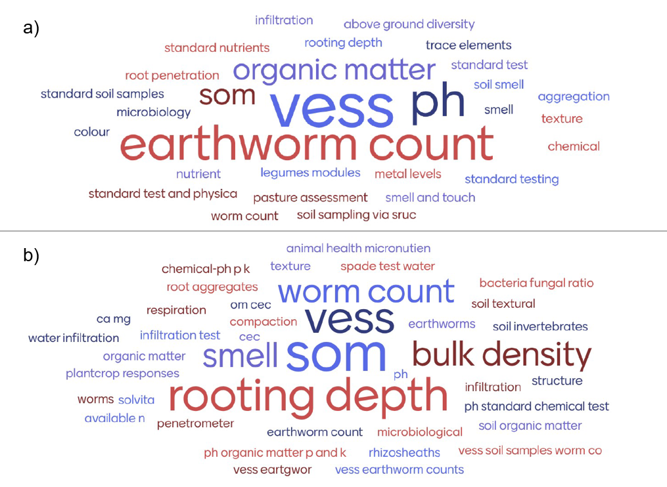

The breakout rooms and guided discussions with thoughts shared on the whiteboards were an effective way to anonymously and efficiently gather information on stakeholder views. The AI summaries of whiteboard posts for both workshops (Table 16) confirmed the Menti survey findings: participants were knowledgeable about measuring soil health and recognised the importance of maintaining soil health to underpin farm productivity, profit and long-term viability. The prioritisation of financial arguments for maintaining soil health is notable in these responses. The AI summary of question 2 (most important factors when choosing a soil health test) confirmed the team’s initial reaction following the workshop: participant opinions diverged between those who were enthusiastic and motivated to use farmer-led methods (e.g. Slake testing, which came up repeatedly in the discussions) and those who wanted a more detailed evaluation of soil biological properties that would only be possible using more advanced laboratory analyses.
Table 16. AI summary of whiteboard responses to four questions about soil health from the stakeholder workshop on early indicators to monitor changes in soil health
Question | AI summary of whiteboard responses
Why is it important to measure soil health? | Participants consistently viewed soil as the farm’s most important asset and emphasised measuring soil health to understand the impacts of management decisions, establish baselines, and monitor change over time. Measurement was seen as key to improving soil function, productivity, and resilience, particularly under increasing climate variability. Several noted the importance of repeat testing and benchmarking. A minority highlighted that measurement is only useful if results are interpretable and actionable. There was also some emphasis on compliance (e.g. SFI), though most responses focused on decision-making, proactive management, and building long-term farm resilience.
What factors are most important when choosing a soil health test? | Cost, ease of use, and clear interpretation were the most frequently cited factors. Participants emphasised the need for tests that are practical, repeatable, and accessible to farmers, with rapid feedback and relevance to management decisions. Many stressed the importance of a clear link to soil function and actionable outcomes. There was strong interest in combining biological, chemical and physical indicators to provide a complete picture. Some participants prioritised biological assessments, while others favoured visual or on-farm methods. A key divergence was between interest in advanced scientific tests and the need for simple, farmer-friendly approaches.
What are the benefits of good soil health for the farm? | There was strong consensus that good soil health underpins productivity, profitability, and resilience. Benefits included improved crop and grass growth, livestock performance, nutrient cycling, and reduced reliance on external inputs. Many highlighted reduced risks (financial, operational, climatic) and improved resilience to drought and extreme weather. Soil health was also linked to better soil structure, reduced compaction, and long-term sustainability of the farm business. Some participants placed particular emphasis on soil biology as the driver of these benefits. Overall, soil health was seen as fundamental to farm performance and long-term viability.
What are the benefits of good soil health for wider society? | Participants highlighted a wide range of societal benefits, particularly relating to ecosystem services. These included improved water quality, reduced flooding, enhanced biodiversity, and carbon storage. Many emphasised links between soil health, food quality, and human health, including nutrient density and reduced reliance on chemical inputs. Soil was widely recognised as a finite, non-renewable resource essential for sustaining life. There was strong emphasis on environmental protection and climate resilience. Some responses were more expansive, linking soil health to public health systems and societal wellbeing, though all reflected the broad importance of soils beyond the farm.

Ranking criteria for evaluating soil health indicators
The qualitative analysis of factors most important when selecting a soil health test were complimented by the results of the Menti surveys where participants were asked to rank criteria for selecting a soil health indicator (Figure 7). Not surprisingly, a clear link to soil health was ranked most important, but ease of interpretation was highlighted as also very important, ahead of sensitivity to management change and low cost.
Figure 7. Ranking of criteria from most to least important when selecting an indicator of soil health.
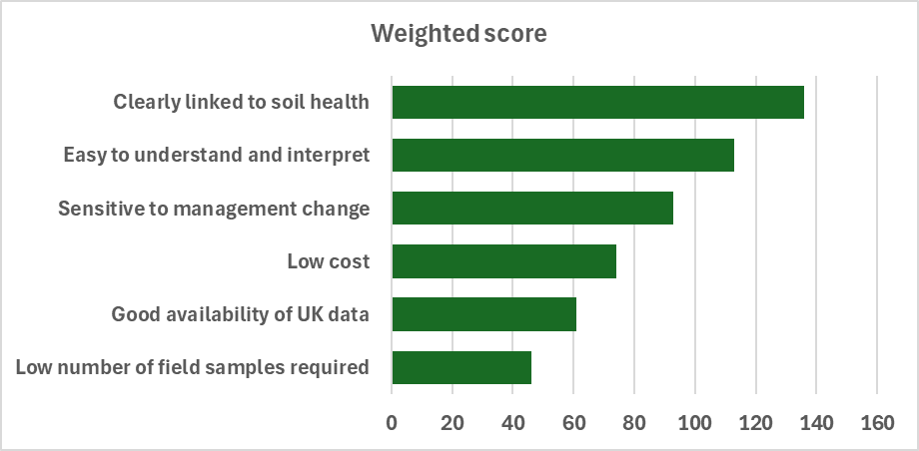I
Figure 7 shows weighted scores for six criteria, displayed as green horizontal bars.
Criteria are ranked from highest to lowest importance:
- Clearly linked to soil health – highest score (longest bar)
- Easy to understand and interpret
- Sensitive to management change
- Low cost
- Good availability of UK data
- Low number of field samples required – lowest score (shortest bar)
The bar lengths decrease steadily from top to bottom, showing a clear priority order.
Overall pattern:
- Direct relevance to soil health and ease of use are the most important factors.
- Practical considerations such as cost and data availability are important but less critical.
- Minimising the number of field samples is the least important criterion.
Ranking ecosystem services from agricultural soils
Workshop participants were asked to rank the ecosystem services provided by agricultural soils (Figure 8). Participants said it was hard to rank how important different soil ecosystem services are. This shows in the results, where water regulation and food production are ranked very similarly.
The climate adaptation benefits (like water absorption and drought resilience) are seen as more important than climate mitigation benefits.
Figure 8. Ranking of ecosystem services from agricultural soils from most to least important
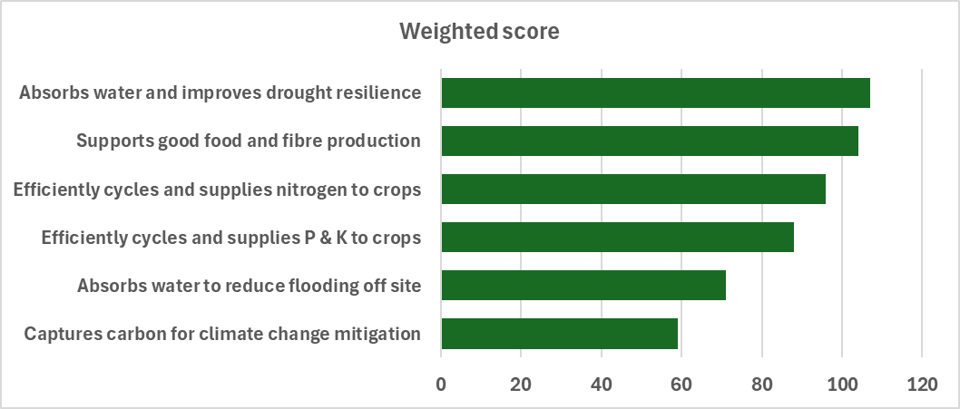
Figure 8 shows weighted scores for six ecosystem services, with green bars decreasing in length from top to bottom.
Services ranked from highest to lowest importance:
- Absorbs water and improves drought resilience – highest score (longest bar)
- Supports good food and fibre production
- Efficiently cycles and supplies nitrogen to crops
- Efficiently cycles and supplies phosphorus and potassium to crops
- Absorbs water to reduce flooding off site
- Captures carbon for climate change mitigation – lowest score (shortest bar)
Overall pattern:
- Water management and food production are ranked as the most important
- Nutrient cycling is also highly valued
- Climate-related benefits are important but ranked lower, with carbon capture lowest

Final ranking of indicators by stakeholders
Before the final voting on the four soil health indicators, participants shared their thoughts using posts on a whiteboard during a second breakout session. The AI summaries of these posts (Table 17) reflected the outcomes of the final voting (Figure 9). Shovelomics and aggregate stability were both viewed positively because of their clear links to soil structure and function. Aggregate stability was interpreted by the participants as referring to the slake test, rather than wet sieving which is the laboratory method for determining aggregate stability. For both of these indicators, their ease of implementation by farmers and low-cost were viewed as positives, although there was recognition that training would be required for reliable, actionable results from these tests. Some uncertainties around active carbon were raised, particularly the question: will it provide additional information to a standard soil organic matter analysis? The comments on potentially mineralisable nitrogen during the workshop surprised the project team, who viewed this as a well-known and recognised test. Various workshop participants flagged the challenges with explaining to farmers what PMN means and how to use the results to make decisions on-farm about soil management.
Table 17. AI summary of whiteboard posts on each of the four indicators and final comments from the stakeholder workshop on early indicators to monitor changes in soil health
Whiteboard themes | AI summary of whiteboard responses
Aggregate stability | Aggregate stability was generally seen as meaningful and relatable, with clear links to soil structure and function. Participants appreciated its visual nature and relevance to farmers, but there was strong concern about it being framed as a laboratory test. Many preferred simple in-field approaches (e.g. slake tests, visual assessment, visual evaluation of soil structure (VESS)), emphasising accessibility and farmer engagement. Questions were raised about benchmarking and interpretation, particularly across soil types. Overall, it was viewed positively, but there was a clear preference for practical, field-based methods over laboratory-based measurements.
Active carbon | Active carbon was seen as potentially useful, particularly in relation to carbon cycling and soil organic matter, but there was uncertainty around interpretation and added value. Participants questioned how it differs from total organic matter and whether it provides actionable insights for management. Some felt it may not respond quickly to change or may simply track existing measures. The complexity of explaining different carbon fractions to farmers was also highlighted. Overall, interest was moderate but tempered by concerns about interpretability, relevance, and practical application.
Crop root architecture (shovelomics) | Crop rooting (shovelomics) was viewed very positively as a practical, farmer-led approach that encourages engagement with soil. Participants valued its simplicity, low cost, and direct link to soil function. However, concerns were raised about subjectivity, consistency, and the need for clear protocols or scoring systems. Some questioned how to benchmark results or compare across fields and systems. Despite these limitations, it was widely seen as a useful and relatable indicator, particularly for on-farm assessment and discussion.
Potentially mineralisable nitrogen (PMN) | PMN was seen as scientifically useful, particularly for estimating nitrogen supply and informing nutrient management, but there were significant concerns about interpretation and usability. Participants noted its relevance to nutrient budgeting and reducing inputs, and its inclusion in existing guidance (e.g. RB209). However, it was often viewed as complex, difficult to communicate, and not easily understood by farmers. Some questioned its added value relative to broader soil biological function. Overall, it was considered promising but currently limited by communication and interpretation challenges.
What have we missed? / preferred metrics | A strong theme was the importance of simple, field-based, and farmer-led assessments. Participants repeatedly emphasised visual and tactile indicators (e.g. digging pits, smell, earthworms, infiltration, compaction) as key to engagement and understanding. Soil biology was highlighted as underrepresented, with interest in microbial assessments, nematodes, and practical proxies (e.g. “bury your pants” test). There was also a call to consider wider land uses beyond agriculture. Overall, respondents stressed accessibility, relatability, and hands-on approaches over complex laboratory methods.

A clear consensus emerged to include shovelomics and aggregate stability (slake test) for further development as early indicators to monitor changes in soil health. The majority of participants did not feel they had enough information to judge whether active carbon or potentially mineralisable nitrogen should be included.
Figure 9. Menti score results from two industry workshops for each shortlisted indicator (PMN, Active C POXC, Shovelomics and aggregate stability). Participants were asked to vote whether the indicator should definitely be included (light blue bars), definitely be excluded (dark blue bars) or they “don’t have enough knowledge to say” (green bars)

Figure 9 shows the number of votes for each indicator across three response options:
- Definitely include (light blue bars)
- Definitely exclude (dark bars)
- Don’t have enough knowledge to say (green bars)
Results by indicator:
PMN
- More respondents said they did not have enough knowledge than supported inclusion
- Smaller numbers supported inclusion or exclusion
Active carbon (POXC)
- Similar to PMN, with many respondents unsure
- Fewer votes for inclusion or exclusion
Shovelomics
- Strong support for inclusion (largest bar in this category)
- Very few votes for exclusion or uncertainty
Aggregate stability
- Also strongly supported for inclusion
- Minimal votes for exclusion or uncertainty
Overall pattern:
Practical, field-based indicators (shovelomics and aggregate stability) are strongly supported.
Indicators like PMN and active carbon have higher uncertainty, with many respondents unsure how to assess them.
The next steps in the project were discussed in a meeting with the AHDB and the project delivery team, bearing in mind the original project aims to:
Provide information to support levy-payers in measuring and monitoring soil health on their own farms, based on an improved understanding of which metrics i) are most practicably suited as sensitive yet robust early indicators of change, backed by validated data, and ii) can be further integrated as an interim measure into a longer-term on-farm soil monitoring regime.
With outputs used to:
update AHDB guidance for farmers on practical soil health assessments and… to complement the AHDB soil health scorecard.
In this meeting the outcomes of the stakeholder workshops as well as feedback from the industry reference group and the evidence review were discussed.
In spite of the stakeholders’ positive response to the information presented on crop rooting/shovelomics, there were some legitimate limitations which resulted in agreement not to include this as a recommended early indicator to monitor changes in soil health. The principal concern related to the limited number of crops with a defined protocol for this method. To date, guidance has only been provided in the UK for cereals. There are published protocols for beans, but the method has not been trialled in the UK yet in pulses. There are also protocols available for maize, but area planted to maize in the UK is limited. Since an early indicator to monitor changes to soil health would need to be evaluated every year, it is unlikely that the same crop (apart from in intensive arable rotations) would be grown in the same field every year; making the applicability of a crop-specific indicator for use as a short-term indicator impractical. It was therefore agreed that only signposting to materials on shovelomics would be provided by the AHDB: specifically, to the factsheet and guidance produced by the TRUTH project (Anon, n.d.).
The clear messaging from the stakeholders on aggregate stability resulted in this being a priority for development of updated guidance material. It was agreed to provide a factsheet explaining the importance of aggregate stability in general, with more specific guidance on using slake testing for farmer-led assessments. Reference would be made to the different apps available for on-farm assessments.
A decision was made to produce factsheets on both active carbon (permanganate oxidisable carbon method (POXC) and potentially mineralisable nitrogen on the basis of stakeholder feedback that these measures were not well understood by end users, was coupled with the relatively positive assessment of these by the Industry Reference Group and their high ranking based on the evidence. Both of these indicators are available from commercial laboratories in the UK which also makes them relatively accessible for use in the field.

Discussion

Potential of shortlisted indicators to detect a change in soil health in 1-2 years
The top three indicators selected for development of further guidance for UK farmers were: active carbon measured using the permanganate oxidisable carbon (POXC) method, potentially mineralisable nitrogen (PMN) and aggregate stability. These have all been proposed as indicators likely to be sensitive to management change.
Deeks & Rickson (2023) report that labile fractions of carbon respond to seasonal variations more than total organic carbon, citing work by Bastida et al. (2006, 2008). Recent research has shown that the ‘active’ soil C component in the soil responds to management change much more quickly (1 to 5 year) (Chéron-Bessou et al., 2025) benefiting the soil stability more than the other pools, improving water infiltration and soil porosity, reducing erosion risk and compaction. Lehmann et al. (2020) also argue that organic carbon fractions are more sensitive than total organic carbon, which does not change so quickly over time. POXC has been proposed as an indicator of the labile carbon fraction in the soil (Rodriguez et al., 2022; Stott, 2019) although the link to labile carbon fractions has been challenged by recent studies (Wade et al., 2021). For example, Woodings & Margenot (2023) revealed some flaws in the assumptions that permanganate oxidises only labile carbon, demonstrating that lignin, part of the soil’s recalcitrant carbon pool, is oxidised by permanganate. For this reason, it is now recommended that the fraction of carbon oxidised in the POXC test not be referred to as labile, but simply as a permanganate-oxidisable carbon. POXC certainly does relate to total organic carbon, as illustrated by Figure 10 which shows a strong relationship with organic matter in a grassland trial at North Wyke and a similarly strong correlation with total organic carbon in a larger project on agricultural soil health in North America (both figures generated from data sourced during this project). Further research is needed to evaluate if recent changes in management will result in a change in POXC more quickly than LOI or soil organic carbon, which are generally acknowledged to be lagging indicators slow to respond to management change.
Figure 10. Relationship between POXC (mg/kg) and two measures of organic matter: loss on ignition and soil organic carbon. Graph a) compares POXC and loss on ignition (%) using results from the North Wyke Inorganic fertiliser trial, 2016. N=330, and b) compares POXC and soil organic C (%) using results from the North American Project to Evaluate Soil Health Measurements (NAPESHM). N=1453.
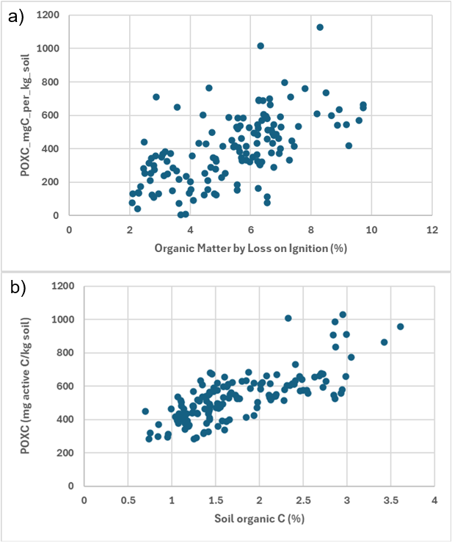
Figure 11. Relationship between PMN (mg/kg) and total soil N (%). North American Project to Evaluate Soil Health Measurements (NAPESHM). N=1453
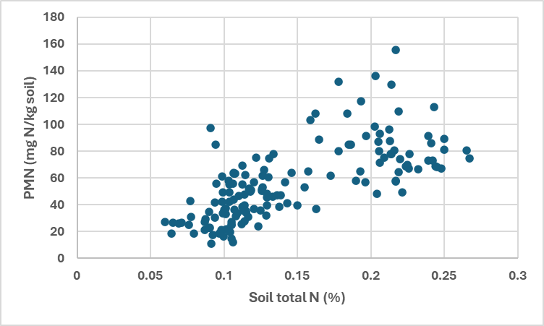
Potentially mineralisable nitrogen is described by Deeks & Rickson (2023) as a combined measure of soil biological activity and substrate available for mineralisation and conversion to plant-available N, but they do not comment on its sensitivity to recent management. It is widely recognised as a guide for making decisions about fertiliser use following recent applications of organic N through manure or slurry, or the plough-down of a legume crop. For detecting changes in soil health as distinct from short-term N supply, it is advisable to sample during a period when the soil has not had recent additions of fresh organic matter. This would provide a better indication of the underlying potential to supply N from the soil’s organic N reserves, reflecting differences in the quality of the soil organic N pool and the microbial community that mineralises organic matter.
Previous work by Bhogal et al. (2020) demonstrated that PMN provides information in addition to standard soil organic matter testing; in their dataset of 625 arable and grassland UK soils, only 23% of the variation in PMN was due to variation in organic matter content.
Data from the NAPESHM project (Norris et al., 2020) shows fairly strong correlation of PMN with soil total N, particularly at lower levels of total N (Figure 11; generated from data sourced during this project). However, at higher levels of total N (>0.15% N) there is a wider spread in PMN values, suggesting that quality of organic nitrogen pools and potential of the soil’s microbial community to mineralise this N, can vary at the same total N value. This could be interpreted as a difference in soil health; with soils with a higher PMN at the same total N level being in better health.
PMN was not the highest ranked indicator based on the review of evidence, largely due to its lower scores in provisioning of water and climate mitigation-related EGS compared to the rest of the shortlist (Table 10). It was also clear in our results from industry feedback in the workshop sessions that there is a need for clear guidance for farmers and advisors on interpreting results from PMN analysis. This is largely reflected in academic interpretations of PMN too: in the sources utilised in the evidence review, PMN is described as “A combined measure of soil biological activity and substrate available to mineralise nitrogen to make it available to the plant” (Deeks & Rickson, 2023), a “soil biological indicator… related main soil functions” (Bünemann et al., 2018), and as having a “relation to nutrient availability and a theorized relationship between microbial activity and plant productivity” (Stott, 2019). While these interpretations all fall largely along the same lines, they do reflect uncertainty in the interpretation of PMN, with no widely accepted citation or definition used.
While there are subtle differences in academic interpretations of PMN, it does largely fall within the label of a biological indicator in academic literature, due to its potential relation to microbial activity e.g. Bonde et al. (1988) This was not however reflected in discussion with farmers and advisors at the industry workshops, in which participants expressed surprise at the shortlist for not including a biological indicator despite PMN being included in the shortlist. This reflects a need for improved understanding of PMN as an indicator, but also the ongoing issue of identifying useful and meaningful biological indicators for soil health.
Aggregate stability is an indicator identified by Deeks & Rickson (2023) as sensitive to soil management, particularly macroaggregation. Macroaggregates (250 μm–2 mm) are more susceptible to disruption by crop management practices making them a potentially useful, sensitive early indicator of changes in soil health (Howe & Smith, 2021; Scow, 1997). Stott (2019) highlight that the aggregate formation integrates soil biological, physical and chemical processes, making it a key indicator of soil health, also highlighting the potential for differences in aggregate stability to be detected just 1-3 years following a management change.
Soil structure and aggregation is evaluated in the current SHSc using VESS. VESS is somewhat limited by the subjectivity of results which are only “semi-quantitative” (Rabot et al., 2018). It is not clear whether VESS scoring is precise enough to detect changes in macroaggregate structure in a short time period; VESS is scored using a discrete scale from 1 (good) to 5 (poor).
Aggregate stability assessed using a wet sieving procedure was the preferred method in this review; however, it is not currently available through commercial laboratories in the UK. Slake testing was a clear favourite among stakeholders since it can be conducted by farmers and there are a number of methods now available, particularly using phone apps. Results of slake testing can be reasonably well correlated with laboratory measures of aggregate stability as illustrated by the results of NAPESHM (Figure 12; generated from data sourced during this project) and various peer-reviewed studies (Fajardo et al., 2025; Flynn et al., 2020; Trybek et al., 2026).
It should be acknowledged that slake testing may be less suitable in some soil types. Adetsu et al. (2024) reported that sandy soils may be less susceptible to slaking due to their larger pore sizes requiring a longer period of immersion in water for the soil aggregate to break apart. In addition, while soil sampling for farmer-led slake testing is simple, there is potential to disrupt aggregates during transport from the field, so care needs to be taken to obtain reliable results.

Figure 12. Relationship between slake testing using a phone app and aggregate stability measured by sprinkle infiltrometer. North American Project to Evaluate Soil Health Measurements (NAPESHM). N=1453
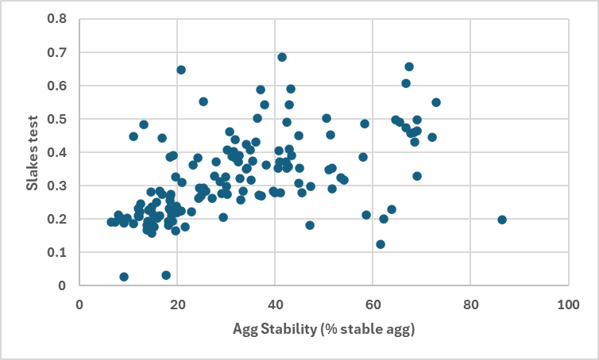

Limitations with biological indicators of soil function
The inclusion of appropriate biological indicators was a key consideration in the selection process for potential early indicators to monitor changes in soil health, acknowledging that the majority of soil processes are interlinked with the living component of the soil (Stone et al., 2016). With this in mind, 7 in the longlist of 10 potential indicators, were biological in nature. These were:
- Earthworms
- CO₂ burst
- Potentially mineralisable nitrogen (PMN)
- Soil foodweb approaches, to assessing soil biota (e.g. including active and total bacteria and fungi and Fungal:Bacterial ratio)
- Phospholipid fatty acids (PLFA)
- Enzyme assays
- Functional gene analysis
The proliferation of biological indicators in the longlist of early indicators to monitor changes in soil health was a response to the clear interest from AHDB levy payers in improving their understanding of soil biology, and a motivation to examine the candidate indicators closely to determine their suitability. However, most of the biological indicators were not shortlisted during the Delphi process by our expert panel. This reflected the developing nature of soil biological assessments.
An indicator of particular interest to workshop participants was the Soil Food Web Approach, as taught through Dr Elaine Ingham’s Soil Food Web School (typical cost for a foundation course is $4,999). Participants noted that the benefits of the approach were that they could carry out the assessment themselves, in their own time, and that the courses were aimed at non-academics. This was reflective of general feedback from workshop participants that they wanted indicators which they could implement themselves, and with immediate results that did not require postage to a laboratory.
As noted by the expert panel, innovative soil biological testing, such as PLFA or enzyme activity approaches, are widely used academically (e.g. van Galen et al., 2025) but are still being developed for commercial application. Limitations include sampling difficulties, as samples for these methods must be rapidly frozen or as fresh as possible, making transportation to appropriate laboratories costly and logistically challenging. A key challenge for these biological tests as soil health indicators is in the strength of the links between indicator results and overall soil health (e.g. Fierer et al., 2021): many of these relationships are theoretical and not well tested in agricultural systems (Semenov et al., 2025). Furthermore, biological indicators are known to be highly variable, both spatially and through time, thus potentially making them too sensitive for use as an early indicator to monitor changes in soil health. These considerations were key in the exclusion of other biological indicators from the recommended shortlist.

Knowledge gaps and future research opportunities
Several knowledge gaps were identified in the indicator selection process.
- At the shortlisting stage through the Delphi process, answers from the expert consultation group contributed to overall understanding of the knowledge gaps associated with the longlisted indicators. Enzymes, Functional Genes, PLFA and Soil Foodweb had the highest number of “unknown” responses to the questions given in the initial survey (Appendix, Figure 14). This limited the ranking that could be achieved by these indicators because it was not possible to attribute scores to unknowns.
- Through project delivery, numerous datasets on PLFA were identified, thus there is potentially value in synthesising results from previous studies to identify key peaks which are particularly relevant to soil health in agricultural systems.
- Enzyme activity assessment is not currently offered in the UK by any commercial laboratories, however the ISO has recently published a standardised method for assessing extracellular enzyme activity in soils (ISO 20130:2018) which covers several hydrolase activities (arylamidase, arylsulfatase, β-galactosidase, α-glucosidase, β-glucosidase, N-acetyl-glucosaminidase, acid, alkaline and global phosphatases, urease). This presents an opportunity for future work investigating the utility and feasibility of commercial testing.
- The existing SHSc indicator boundaries were first introduced eight years ago, and it is expected that updating the interpretation boundaries to incorporate texture, land use (grassland/arable) would require targeted data collection.
- The measurement of aggregate stability in the field via smartphone apps to facilitate slake testing presents a promising future avenue for soil structural testing. While there are already efforts underway to test and validate more novel, technology driven soil health testing (e.g. the Ai4SoilHealth project - https://ai4soilhealth.eu/), there is currently a lack of testing on UK agricultural soils. Future work focussing on rolling out these assessments on UK agricultural soils to establish meaningful interpretations and ensure results validity would be a valuable contribution to this field.
- Another area of soil health testing which was considered during project delivery was olfactory assessment, or “sniff testing” of soil to determine properties. At the stakeholder workshops, some farmers and advisors reported that they regularly sniffed their soils to determine overall health. More recent research has considered the utility of olfactory assessment to identify volatile compounds from soil, and this represents a potentially exciting future avenue for soil assessment with further development. Likewise, eco-acoustics is being developed for monitoring of some soil fauna (see Robinson et al. 2024).
- It was not possible to conclusively state that POXC is a good measure of the active carbon pool in the soil. Figure 10 shows a strong correlation between POXC and soil organic matter/soil carbon. Further studies are required to evaluate if POXC provides an early indication of changes in soil organic carbon/matter. This would require measurement on an annual basis in trials where long-term changes in soil organic matter are expected (e.g. manure amendment trials, arable-ley rotations) or have been documented. There may also be potential to return to archived soil samples from long-term trials to investigate if POXC changes were present earlier than changes in soil organic matter/carbon. Sample archives such as those at Rothamsted Research may provide a valuable resource for this sort of study.
- While a decision was made not to pursue development of an improved interpretation framework for earthworms within this project, the searches of open-access data repositories returned 13 datasets with potential for mining to refine the existing SHSc advice on earthworms. There is potential to delve into this data and improve the traffic light system for earthworms, especially because some of these datasets include reference to useful explanatory variables, e.g. soil texture.
- Overall, there is a tendency for soil health research to focus on a familiar subset of indicators which are already well used and understood academically. While this is understandable, our results showed the importance of conducting research on indicators which are less well established in the literature to ensure that their potential utility as soil health metrics is not overlooked.

References
Adetsu, D. V., Arthur, E., Fu, Y., Cornelis, W., & Lamandé, M. (2024). Exploratory assessment of the SLAKES method to characterize aggregate stability across diverse soil types. Soil Science Society of America Journal, 88(4), 1086–1099. https://doi.org/10.1002/saj2.20674
AHDB. (2022). Soil Health scorecard approach Sampling protocol and benchmarking tables England and Wales.
Anon. (n.d.). Root Rangers Cereal Shovelomics Protocol. Thriving Roots Underpinning Total soil Health (TRUTH).
Bastida, F., Moreno, J. L., Hernandez, T., & Garcia, C. (2006). Microbiological degradation index of soils in a semiarid climate. Soil Biology and Biochemistry, 38(12), 3463–3473.
Bastida, F., Zsolnay, T., Hernandez, T., & Garcia, C. (2008). Past, present and future of soil quality indices: A biological perspective. Geoderma, 147(3–3), 159–171.
Bhogal, A., Blake-Kalff, M., Rose, D., Pitcher, S., Watson, C., & Stockdale, E. (2020). Soil Biology and Soil Health Partnership Project 11: Developing UK-relevant benchmarks for the soil health indicators: Potentially Mineralisable Nitrogen and Solvita respiration burst.
Black, H. I. J. ;, Ritz, K. ;, Campbell, C. D. ;, Black, H. I. J., Ritz, K., Campbell, C. D., Harris, J. A., Wood, C., Chamberlain, P. M., Parekh, N., Towers, W., & Scott, A. (2008). SQID: Prioritising biological indicators of soil quality for deployment in a national-scale soil monitoring scheme Summary report. http://nora.nerc.ac.uk/policies.html#access
Bonde, T. A., Schnürer, J., & Rosswall, T. (1988). Microbial biomass as a fraction of potentially mineralizable nitrogen in soils from long-term field experiments. Soil Biology and Biochemistry, 447–452.
Bünemann, E. K., Bongiorno, G., Bai, Z., Creamer, R. E., De Deyn, G., de Goede, R., Fleskens, L., Geissen, V., Kuyper, T. W., Mäder, P., Pulleman, M., Sukkel, W., van Groenigen, J. W., & Brussaard, L. (2018). Soil quality – A critical review. In Soil Biology and Biochemistry (Vol. 120, pp. 105–125). Elsevier Ltd. https://doi.org/10.1016/j.soilbio.2018.01.030
Chéron-Bessou, C., Beillouin, D., Thoumazeau, A., Chapuis-Lardy, L., Chevallier, T., Demenois, J., & Nelson, P. N. (2025). A global database on land use and management change effects on soil KMnO4-oxidisable organic carbon (POXC). Scientific Data , 12(1). https://doi.org/10.1038/s41597-025-05976-9
Cheviron, N., Grondin, V., Marrauld, C., Poiroux, F., Bertrand, I., Abadie, J., Pandard, P., Riah-Anglet, W., Dubois, C., & Malý, S. (2022). Inter-laboratory validation of an ISO test method for measuring enzyme activities in soil samples using colorimetric substrates. Environmental Science and Pollution Research, 29, 29348–29357. https://doi.org/10.1007/s11356-021-17173-3ï
Collier, S. M., Green, S. M., Inman, A., Hopkins, D. W., Kendall, H., Jahn, M. M., & Dungait, J. A. J. (2021). Effect of farm management on topsoil organic carbon and aggregate stability in water: A case study from Southwest England, UK. Soil Use and Management, 37(1), 49–62. https://doi.org/10.1111/sum.12658
Deeks, L., & Rickson, J. (2023). Towards Indicators of Soil Health Annex 1: Review and evaluation of existing soil health indicators being used in the UK and internationally. https://hub.jncc.gov.uk/assets/71cece04-eef3-4d34-b118-33ddad50912c#jncc-report-737-
Emmett, B., Fay, E., & Heaton-Davies, T. (2024). Visualisation of National Soil Monitoring Schemes: An Overview of National Soil Monitoring Schemes Across the Four Nations of the UK. LUNZ Soil TAG project. https://doi.org/https://lunzhub.com/resources/approaches-to-nationwide-soil-monitoring-across-the-uk/
Fajardo, M., Pino, V., Jones, E., Morgan, C., Stevenson, B., Saby, N., Lacoste, M., & McBratney, A. (2025). Measuring soil aggregate stability with mobile phones, lessons, challenges, and future work. Scientific Reports, 15(1). https://doi.org/10.1038/s41598-025-09925-9
Fierer, N., Wood, S. A., & Bueno de Mesquita, C. P. (2021). How microbes can, and cannot, be used to assess soil health. Soil Biology and Biochemistry, 153, 108111. https://doi.org/10.1016/j.soilbio.2020.108111
Flynn, K. D., Bagnall, D. K., & Morgan, C. L. S. (2020). Evaluation of SLAKES, a smartphone application for quantifying aggregate stability, in high-clay soils. Soil Science Society of America Journal, 84(2), 345–353. https://doi.org/10.1002/saj2.20012
Franzluebbers, A. J., Haney, R. L., Honeycutt, C. W., Schomberg, H. H., & Hons, F. M. (2000). Flush of Carbon Dioxide Following Rewetting of Dried Soil Relates to Active Organic Pools. Soil Science Society of America Journal, 64(2), 613–623. https://doi.org/10.2136/sssaj2000.642613x
Frewer, L. J., Fischer, A. R. H., Wentholt, H. J. P., Marvin, B. W., Ooms, D., Coles, D., & Rowe, g. (2011). The use of Delphi methodology in agrifood policy development: Some lessons learned, Technological Forecasting and Social Change. Technological Forecasting and Social Change, 78(9), 1514–1525.
Fuka, M. M., Engel, M., Gattinger, A., Bausenwein, U., Sommer, M., Munch, J. C., & Schloter, M. (2008). Factors influencing variability of proteolytic genes and activities in arable soils. Soil Biology and Biochemistry, 40(7), 1646–1653. https://doi.org/10.1016/j.soilbio.2008.01.028
Ghani, A., Dexter, M., & Perrott, K. W. (2003). Hot-water extractable carbon in soils: a sensitive measurement for determining impacts of fertilisation, grazing and cultivation. Soil Biology and Biochemistry, 35(9), 1231–1243.
Haney, R. L., Hons, F. M., Sanderson, M. A., & Franzluebbers, A. J. (2001). A rapid procedure for estimating nitrogen mineralization in manured soil. Biology and Fertility of Soils, 33, 100–104.
Howe, J. A., & Smith, A. P. (2021). The soil habitat. Principles and Applications of Soil Microbiology, Third Edition, 23–55. https://doi.org/10.1016/B978-0-12-820202-9.00002-2
Keeney, D. R. (1982). 35 Nitrogen - Availablity Indices: Part 2 (A. L. Page, R. H. Miller, & D. R. Keeney, Eds.). American Society of Agronomy, Inc.; Soil Science Society of America, Inc.
Kemper, W. D., & Rosenau, R. C. (1986). Aggregate Stability and Size Distribution. In A. Klute (Ed.), Methods of Soil Analysis: Part 1 Physical and Mineralogical Methods (pp. 425–442). American Society of Agronomy, Inc.; Soil Science Society of America, Inc.
Lehmann, J., Bossio, D. A., Kögel-Knabner, I., & Rillig, M. C. (2020). The concept and future prospects of soil health. In Nature Reviews Earth and Environment (Vol. 1, Number 10, pp. 544–553). Springer Nature. https://doi.org/10.1038/s43017-020-0080-8
Lucas, S. T., & Weil, R. R. (2012). Can a Labile Carbon Test be Used to Predict Crop Responses to Improve Soil Organic Matter Management? . Agronomy Journal, 104, 11601170.
Moebius-Clune, B. Nadine., Moebius-Clune, D. J., Gugino, B. K., Idowu, O. J., Schindelbeck, R. R., Ristow, A. J., van Es, H. M., Thies, J. E., Shayler, H. A., McBride, M. B., Kurtz, K. S. M., Wolfe, D. W., & Abawi, G. S. (2016). Comprehensive assessment of soil health : the Cornell framework manual (Third Edition). Cornell University.
Norris, C. E., Bean, G. Mac, Cappellazzi, S. B., Cope, M., Greub, K. L. H., Liptzin, D., Rieke, E. L., Tracy, P. W., Morgan, C. L. S., & Honeycutt, C. W. (2020). Introducing the North American project to evaluate soil health measurements. In Agronomy Journal (Vol. 112, Number 4, pp. 3195–3215). John Wiley and Sons Inc. https://doi.org/10.1002/agj2.20234
Norton, J. M., Alzerreca, J. J., Suwa, Y., & Klotz, M. G. (2002). Diversity of ammonia monooxygenase operon in autotrophic ammonia-oxidizing bacteria. Archives of Microbiology, 177, 139–149.
Orr, C. H., Leifert, C., Cummings, S. P., & Cooper, J. M. (2012). Impacts of Organic and Conventional Crop Management on Diversity and Activity of Free-Living Nitrogen Fixing Bacteria and Total Bacteria Are Subsidiary to Temporal Effects. PLoS ONE, 7(12), e52891. https://doi.org/10.1371/journal.pone.0052891
Rabot, E., Wiesmeier, M., Schlüter, S., & Vogel, H. J. (2018). Soil structure as an indicator of soil functions: A review. In Geoderma (Vol. 314, pp. 122–137). Elsevier B.V. https://doi.org/10.1016/j.geoderma.2017.11.009
Ramsey, P. W., Rillig, M. C., Feris, K. P., Holben, W. E., & Gannon, J. E. (2006). Choice of methods for soil microbial community analysis: PLFA maximizes power compared to CLPP and PCR-based approaches. Pedobiologia, 50(3), 275–280. https://doi.org/10.1016/j.pedobi.2006.03.003
Rillig, M. C. (2004). Arbuscular mycorrhizae, glomalin, and soil aggregation. Canadian Journal of Soil Science, 84(4), 353–363.
Ritz, K., Black, H. I. J., Campbell, C. D., Harris, J. A., & Wood, C. (2009). Selecting biological indicators for monitoring soils: A framework for balancing scientific and technical opinion to assist policy development. Ecological Indicators, 9(6), 1212–1221. https://doi.org/10.1016/j.ecolind.2009.02.009
Robinson, J. M., Annells, A., Cavagnaro, T. R., Liddicoat, C., Rogers, H., Taylor, A., & Breed, M. F. (2024). Monitoring soil fauna with ecoacoustics. In Proceedings of the Royal Society B: Biological Sciences (Vol. 291, Number 2030). Royal Society Publishing. https://doi.org/10.1098/rspb.2024.1595
Rocci, K. S., Cotrufo, M. F., Ernakovich, J., Foster, E., Frey, S., Georgiou, K., Grandy, A. S., Malhotra, A., Reich, P. B., Schlerman, E. P., & Wieder, W. R. (2024). Bridging 20 Years of Soil Organic Matter Frameworks: Empirical Support, Model Representation, and Next Steps. In Journal of Geophysical Research: Biogeosciences (Vol. 129, Number 6). John Wiley and Sons Inc. https://doi.org/10.1029/2023JG007964
Rodriguez, S., Baeza, M. C., García, G. V., Domínguez, G. F., Clemente, N. L., & Studdert, G. A. (2022). Permanganate Oxidizable Carbon, New Soil Health Indicator for Mollisols of the Southeastern Argentinean Pampas? In Communications in Soil Science and Plant Analysis (Vol. 53, Number 16, pp. 2029–2044). Taylor and Francis Ltd. https://doi.org/10.1080/00103624.2022.2070631
Scow, K. (1997). 11 - Soil Microbial Communities and Carbon Flow in Agroecosystems. In L. Jackson (Ed.), Ecology in Agriculture (pp. 367–413). Academic Press.
Semenov, M. V., Zhelezova, A. D., Ksenofontova, N. A., Ivanova, E. A., Nikitin, D. A., & Semenov, V. M. (2025). Microbiological Indicators for Assessing the Effects of Agricultural Practices on Soil Health: A Review. In Agronomy (Vol. 15, Number 2). Multidisciplinary Digital Publishing Institute (MDPI). https://doi.org/10.3390/agronomy15020335
Sharifi, M., Zebarth, B. J., Burton, D. L., Grant, C. A., & Cooper, J. M. (2007). Evaluation of Some Indices of Potentially Mineralizable Nitrogen in Soil. Soil Science Society of America Journal, 71, 1233–1239.
Stone, D., Ritz, K., Griffiths, B. G., Orgiazzi, A., & Creamer, R. E. (2016). Selection of biological indicators appropriate for European soil monitoring. Applied Soil Ecology, 97, 12–22. https://doi.org/10.1016/j.apsoil.2015.08.005
Stott, D. E. (2019). Recommended Soil Health Indicators and Associated Laboratory Procedures.
Trybek, M., Algarin, C. A. V., Grande, L. H. Q., Sebim, J. P. M., Canisares, L. P., Morgan, C. L. S., Cerri, C. E. P., & Cherubin, M. R. (2026). Aggregate stability measurements of tropical soils under conservation agriculture using the Slakes smartphone app. Soil and Tillage Research, 257, 106984. https://doi.org/10.1016/j.still.2025.106984
van Galen, L. G., Smith, G. R., Margenot, A. J., Waldrop, M. P., Crowther, T. W., Peay, K. G., Jackson, R. B., Yu, K., Abrahão, A., Ahmed, T. A., Alatalo, J. M., Anslan, S., Anthony, M. A., Araujo, A. S. F., Ascher-Jenull, J., Bach, E. M., Bahram, M., Baker, C. C. M., Baldrian, P., … van den Hoogen, J. (2025). A global database of soil microbial phospholipid fatty acids and enzyme activities. Scientific Data , 12(1). https://doi.org/10.1038/s41597-025-05759-2
Wade, J., Chongyan, L., Mirjam, M., Pulleman, G., Trankina, G., Wills, S. A., & Margenot, A. J. (2021). To standardize by mass of soil or organic carbon? A comparison of permanganate oxidizable carbon (POXC) assay methods. Geoderma, 404, 115392.
Woodings, F. S., & Margenot, A. J. (2023). Revisiting the permanganate oxidizable carbon (POXC) assay assumptions: POXC is lignin sensitive. Agricultural and Environmental Letters, 8(1). https://doi.org/10.1002/ael2.20108

Appendices

Results of first survey provided to Delphi respondents before completing the second survey

Early Indicators of Soil Health – Initial Survey Results Summary
Survey respondents were asked a series of questions to rate the selected shortlist of 10 potential early indicators of soil health across seven criteria. The criteria were:
- Confidence that there is robust, UK relevant data (Data)
- Cost to client for analysis (Expense)
- Confidence that changes in the indicator will show a change in soil health (Health)
- Samples required to represent an area (Samples)
- Confidence in indicator sensitivity to management change (Sensitivity)
- Confidence that the indicator results are useful to farmers (Utility)
- Spatial variability associated with this indicator (Spatial)
Responses were mapped numerically, where a high number was assigned to a positive response (i.e. “Very confident” that changes in the indicator will show a soil health change). Total scores for each indicator across the criteria were used to compile the initial ranking, with equal weighting assigned to each criterion. Spatial variability was excluded from the initial ranking as it was not practical to assign a positive or negative response to this criterion.
Table 18. Initial ranking of indicators from results of first survey responses (n = 6)
Indicator | Preliminary Rank
Earthworms | 1
PMN | 2
Crop Rooting | 3
CO₂ Burst | 4
Water Stable Aggregates | 5
Soil C Fractions | 6
Functional genes (qPCR) | 7
Soil Foodweb | 8
Enzymes | 9
PLFA | 10

The preliminary ranking showed that recently emerging biological indicators had lower median scores than better established indicators (Table 18). The preliminary top indicator, earthworm counts, scored highly with most participants across criteria 1 – 3 and 5 – 6 (Figure 13). This was in contrast to Enzymes, PLFA, Functional Genes and Soil Foodweb, none of which scored highly across any of the criteria considered (Figure 13).

Figure 13 Breakdown of the criteria score contributing to ranking of indicators from results of first survey responses (n = 6)
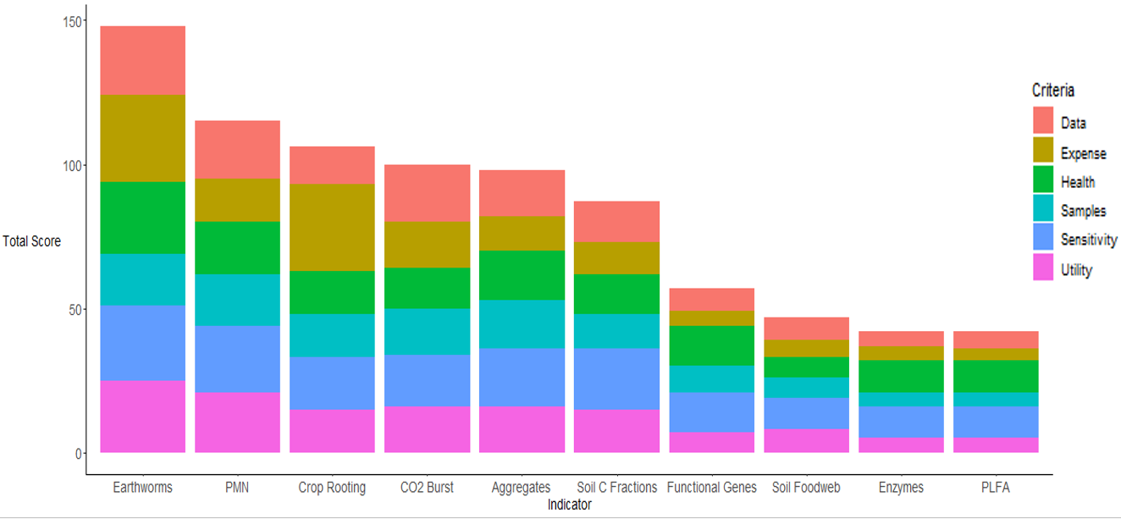
From highest to lowest, earthworms scored around 150 in total, PMN and Crop rooting between 100 and 125, CO₂ burst, Aggregates and soil C fractions between 75 and 100, Functional genes between 50 and 75 and soil foodweb, enzymes and PLFA between 25 and 50
Results for each criterion presented in Figure 13:
- Confidence that there is robust, UK relevant data; earthworms scored the highest, enzymes and PLFA scored the lowest
- Cost to client for analysis (expense); earthworms and crop rooting scored the highest, PLFA and enzymes scored the lowest
- Confidence that changes in the indicator will show a change in soil health; earthworms scored the highest and soil foodweb scored the lowest
- Samples required to represent an area; earthworms and PMN scored the highest and enzymes and PLFA scored the lowest
- Confidence in indicator sensitivity to management change; earthworms scored the highest and soil foodweb, enzymes and PLFA scored the lowest
- Confidence that the indicator results are useful to farmers (utility); earthworms scored the highest and enzymes and PLFA scored the lowest,
Overall pattern:
Physical and biological indicators such as earthworms, aggregate stability, crop rooting, PMN and CO₂ burst are scored the highest.
More complex or laboratory-based measures, such as functional genes, soil foodweb, enzymes and PLFA are scored the lowest.
This is in a large part attributable to the knowledge gaps associated with the indicators included. In each question of the survey, participants were given the option to state where they felt that they did not have enough knowledge of the indicator to assess it against the criteria (unknown). Enzymes, Functional Genes, PLFA and Soil Foodweb had the highest number of “unknown” responses to the questions given in the survey and earthworms and PMN had the lowest (Figure 14)
Figure 14. Total number of responses for each indicator where participants felt they did not know enough about the indicator to be able to assess it against each criterion (“unknowns”).
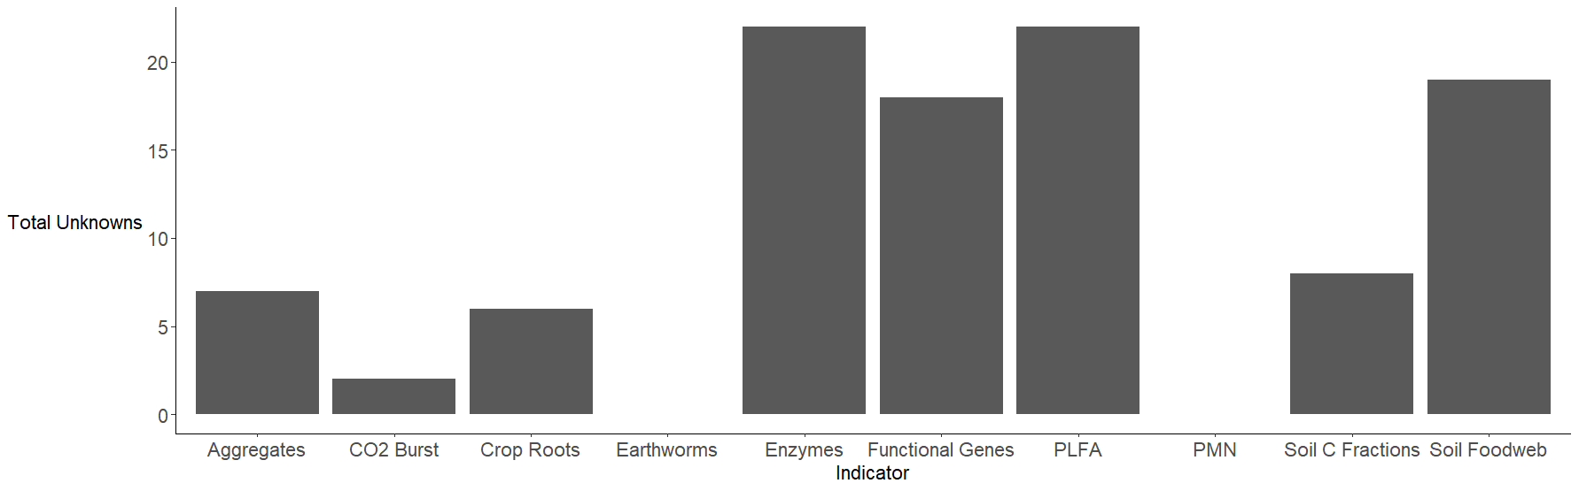
From highest to lowest, the number of “unknown” responses were; Enzymes and PLFA indicators (joint highest) with over 20, followed by Soil Foodweb and functional genes (over 15). Between 5 and 10 “Unknown” responses were received for soil C fractions, aggregates and crop roots, whilst CO₂ burst had less than 5 responses and Earthworms and PMN had no “unknown” responses.
Overall the more complex biological tests (enzymes, functional genes, PLFA and soil foodweb) had the highest number of “unknown” responses. Whilst more established biological methods (CO₂ burst, PMN, soil C fractions and earthworms) and physical measures (aggregates and crop roots) had much lower or zero “unknown” responses.
There was also limited consensus on the capacity of each of the given indicators to impact ecosystem goods and services. Summarised participant rankings for each indicator showed that many indicators were considered to have strong links to soil nutrient cycling, particularly N, while drought regulation was less highly ranked for any of the given indicators (Table 19).

Delphi Survey – second round – conversion of ranked importance of criteria and ecosystem goods and services into weightings
- Rankings from respondents were converted into an average rank for each criteria/EGS.
- Average ranks were converted into a score for each criteria/EGS (j) using the formula: ${\text{score}}_{j}=m-r_{j}+1$ where m=the total number of criteria/EGS and r_{j} is the average rank for that score.
- All the scores were summed; in this case the sum=21 for both criteria and EGS.
- Scores for each criteria/EGS were converted into weightings to be used in the Logical sieve using this formula: $w_{j}=\frac{{\text{score}}_{j}}{21}$ where w=weighting for j criteria/EGS.

Table 19. Average ranking (first=1, second=2, etc) for the capacity of each indicator to reflect given ecosystem service. Top ranked indicator for each service is marked with an asterisk.
Indicator | Soil carbon storage for climate mitigation | Food, fibre and biomass productions | Nutrient cycling - provision of N to crops | Nutrient cycling - provision of P & K to crops | Water regulation - drought mitigation | Water regulation - flood alleviation/ runoff/ erosion mitigation
Earthworms | 4.8 | 2.2* | 3.5 | 4.0 | 4.7 | 1.8*
CO₂ Burst | 2.5 | 3.5 | 2.0 | 3.3 | 5.3 | 4.3
PMN | 3.3 | 2.5 | 1.0* | 3.7 | 5.7 | 4.8
Soil Foodweb | 4.7 | 3.7 | 1.3 | 1.7* | 4.7 | 5.0
Crop Roots | 5.5 | 2.0 | 3.0 | 4.0 | 3.3 | 3.3
Soil C Fractions | 1.6* | 3.6 | 3.4 | 4.4 | 4.4 | 3.6
PLFA | 4.0 | 4.0 | 1.0* | 2.0 | 5.5 | 4.5
Enzymes | 3.5 | 5.0 | 1.0* | 2.0 | 4.5 | 5.0
Functional Genes | 3.0 | 4.5 | 1.0* | 2.0 | 5.5 | 5.0
Aggregates | 3.6 | 3.4 | 4.0 | 5.0 | 3.0* | 2.0

Outline of final stakeholder workshops
Table 20. Outline of final stakeholder workshops
Workshop task | Content
Introduction to the project and context | Presentation: What are soil health indicators? Introduction to the current SHSc. Explanation about the need for early indicators.
First participant Menti survey | Q1: Do you currently conduct soil health testing on your farm or through your business? (yes/no)  Q2: What soil health tests do you use most frequently? (wordcloud)  Q3: Can you provide a few words to describe the features of a useful soil health indicator? (free text)
First breakout room – introduction | Presentation: What criteria have we been using to evaluate early indicators to monitor soil health?
First breakout room – discussions | Moderated discussion with whiteboard; guiding questions – Why do you think it is important to measure soil health? What factors are most important to you when deciding which soil health test to use? What are the benefits of good soil health for the farm? What are the benefits of good soil health to wider society?
Second participant Menti survey | Q1: Put the following criteria in order from most important to least important when selecting an indicator of soil health. (Sensitive to management change, Good availability of UK data, Low cost, Low number of field samples required, Easy to understand and interpret, Clearly linked to soil health)  Q2: Put the following ecosystem services from agricultural soils in order from most important to least important. (Efficiently cycles and supplies nitrogen to crops, Efficiently cycles and supplies P & K to crops, Absorbs water to reduce flooding off site, Absorbs water and improves drought resilience, Captures carbon for climate change mitigation, Supports good food and fibre production)  Q3: Have we missed out any important criteria? please let us know below. (free text)
Shortlisting of indicators so far | Presentation: Delphi process and expert input; outcomes of expert shortlist for more in-depth evidence review
Summary of each indicator method | Presentations: What it is, what it tells us, what we have learned from the evidence review on the criteria
Second breakout room – discussions and group feedback | Moderated discussion with whiteboard; focused on reactions to the four indicators identified: Aggregate stability, Active carbon, Crop root architecture (“shovelomics”), Potentially mineralisable nitrogen. Also, comments on: What have we missed? Your preferred metrics of soil health
Third participant Menti survey | For each of the four indicators, participants voted to “Definitely include”, “Definitely exclude” or “I don't have enough knowledge to say”. They were also provided with a final opportunity to comment in response to: “Would you like to add any further comments on choice of early indicators of soil health?”
Final remarks/next steps | Informal wrap-up, discussion of next steps


Factsheet content
Updated “explainer” factsheet content for knowledge exchange on the utility and value of PMN, active carbon (POXC) and aggregate stability as early indicators to monitor changes in soil health.

Explainer for potentially mineralisable nitrogen
- Tests the ability of the microbial community to supply plant available nitrogen
- Outcome of active soil biology
- Influenced by agricultural management practices
- Indicates changes in soil health more rapidly than soil organic matter changes
- Widely offered test from commercial laboratories
With so much interest in soil health these days, many farmers are looking for properties they can measure to tell them how their soil management is affecting their soil’s health. The current soil health indicators in AHDB’s soil health scorecard are recommended for testing every 3 to 5 years, but farmers are looking for indicators that will tell them sooner how a recent change in management has affected their soil health. These early indicators to monitor changes in soil health need to be sensitive to management, but not so sensitive that they will be affected by recent weather or land operations. This factsheet summarises how potentially mineralisable nitrogen can be used as an early indicator to monitor a change in soil health.

What is potentially mineralisable nitrogen?
Potentially mineralisable nitrogen - sometimes referred to as PMN – is the proportion of the organic nitrogen in soil that can be converted into plant available (or mineral) nitrogen (ammonium and nitrate) by soil microbes.
Plants need to take up nitrogen to grow successfully. Nitrogen exists in several forms in soil and the easiest forms for plants to use are mineral forms including ammonium and nitrate. Most nitrogen enters the soil system as organic nitrogen – nitrogen built into dead and decaying plant and animal material – this material must be degraded by soil microbes to be transferred into the plant available, mineral nitrogen pool.
Understanding the ability of the soil microbial community to convert organic nitrogen into plant available nitrogen can help inform nutrient planning and potentially reduce the amount of synthetic nitrogen needed during particular stages of crop growth. This will be particularly important in organic or other low input systems.
The PMN test is a direct measure of one biological aspect of soil health – the ability to transfer nitrogen stored in the organic pool in soil (decomposing plant or animal material) to the inorganic, plant and microbe available pool. This process is essential to both plant and microbial growth and, particularly in low input systems, is a key aspect of soil health.

What controls PMN?
Soil mineral nitrogen is influenced in various ways. From a biological perspective soil mineral nitrogen is supplied by the soil microbial community (Zhaoli et al.) although in conventional UK agriculture the addition of synthetic fertiliser may supersede the supply from PMN. Soil PMN is controlled or influenced by various factors, some of which can be managed and some of which cannot.

Manageable controls

Cultivation
Cultivation results in in higher PMN within season (Rasmussen et al., 1998) however, repeated cultivation particularly without organic matter inputs can lead to reduced PMN in the long term because of reduced organic matter concentrations (Mahal et al., 1998).
There is also evidence that conservation tillage practices can result in higher PMN (Mahal et al., 1998).

Organic matter inputs
Soil with higher levels of organic matter tend to have higher PMN although this will be mediated by soil texture. This means that systems with high levels of organic matter return to the soil will likely have higher PMN (Spargo et al., 2011).
Organic matter type is also likely important, organic matter with higher nitrogen concentrations will likely result in higher PMN (Osterholz et al., 2017).

Soil structure
Soils with a higher proportion of small aggregates (e.g. crumbs less than 2mm across) tend to have higher PMN (Bimüller et al., 2016) likely because the organic matter is less physically protected from degradation by soil microbes.

Un-manageable controls

Climate
Humid areas tend to have higher rates of PMN than dry areas.

Soil texture
Very heavy soils with lots of clay may protect organic nitrogen from conversion to plant available forms by microbes.
Lighter soils will have smaller microbial communities although their ability to carry out PMN is often higher making it difficult to predict this complex relationship (Hassink, 1997).

How is PMN measured?
Potentially mineralizable nitrogen is measured in a laboratory using a soil sample such as might be collected for standard soil nutrient or pH testing. Once the sample is collected, it should be kept cold (4°C if possible) and delivered to the laboratory as soon as possible. On arrival at the laboratory two portions of the sample will be weighed out (Figure 15) the first will be shaken with a mild salt solution to extract the ammonium and nitrate. The second portion of soil will be incubated for seven days in a tube filled with water to keep out any oxygen. This will allow the microbes in the soil to continue to degrade organic matter nitrogen into mineral nitrogen but prevent any further use of the resulting ammonium and nitrate. This means that the mineral nitrogen accumulates in the second sample, the difference in mineral nitrogen concentration between the second and first samples is the potentially mineralisable nitrogen.
Figure 15. The potentially mineralisable nitrogen test involves measuring the mineral nitrogen concentration on two portions of a single soil sample to understand how quickly the microbes in the soil can turn organic nitrogen into plant available mineral nitrogen.
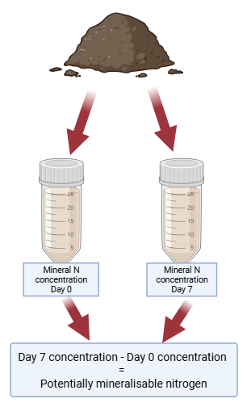
Timing matters when testing for potentially mineralisable nitrogen. Accounting for the potential supply of nitrogen from organic materials when deciding on fertiliser additions, testing in late winter for spring sowing is sensible. For autumn sowing, testing in late summer will give a good picture of the potential supply of nitrogen. It is important to remember that PMN represents the amount of nitrogen released from the organic matter in the soil under ideal laboratory conditions. In the field this will vary based on factors such as temperature and moisture. It is important to remember that any additional organic matter added to the soil after testing occurs (e.g. late terminated cover crops, FYM or slurry addition, or weeds incorporated into soil prior to sowing) will change the stock of organic material available for mineralisation and hence the amount of PMN.

What do the results of my PMN test mean?
Potentially mineralisable nitrogen reflects an aspect of biological soil health by measuring how well the microbial community in the soil works to carry out the conversion of nitrogen from the organic matter pool into the plant available pool in the soil.
The results of a PMN test will likely report milligrams of N per kilogram of soil (mg/kg), most testing labs will also give an interpretation of whether the concentration is high, moderate or low. The AHDB soil health score card has some guideline bands for the interpretation of PMN results as shown below. This may differ from results reported by the testing lab as some are beginning to take into account aspects of the soil discussed above – for example soil texture and organic matter content. This is advantageous as it should give a more accurate estimate of the real potential of the soil to carry out nitrogen mineralisation rather than measuring it against an unattainably high standard or being overly confident that PMN is fine when the values for a particular soil type should actually be classed as low.
Table 21. Benchmark table for PMN taken from the soil health scorecard with additional details on possible reasons for the results.
Traffic light | PMN (mg/kg) | Interpretation | Possible reasons
Investigate  (Red) | <27 | Very low | Low organic matter, sandy texture, dry soil, poor soil structure, small soil microbial community
Review  (Amber) | 28-40 | Low (below average) | Low organic matter, sandy texture, dry soil, poor soil structure, small soil microbial community
Monitor  (Green) | >40 | Typical | Good level of organic matter, good soil structure, good water balance (well drained but not droughty), fine textured soil.

PMN factsheet references
Li, Z., Tian, D., Wang, B., Wang, J., Wang, S., Chen, H.Y.H., Xu, X., Wang, C., He, N., Niu, S., 2019. Microbes drive global soil nitrogen mineralization and availability. Global Change Biology 25, 1078–1088. https://doi.org/10.1111/gcb.14557
Mahal, N.K., Castellano, M.J., Miguez, F.E., 2018. Conservation Agriculture Practices Increase Potentially Mineralizable Nitrogen: A Meta-Analysis. Soil Science Society of America Journal 82, 1270–1278. https://doi.org/10.2136/sssaj2017.07.0245
Rasmussen, P.E., Douglas, C.L., Collins, H.P., Albrecht, S.L., 1998. Long-term cropping system effects on mineralizable nitrogen in soil. Soil Biology and Biochemistry 30, 1829–1837. https://doi.org/10.1016/S0038-0717(98)00057-1
Spargo, J.T., Cavigelli, M.A., Mirsky, S.B., Maul, J.E., Meisinger, J.J., 2011. Mineralizable soil nitrogen and labile soil organic matter in diverse long-term cropping systems. Nutr Cycl Agroecosyst 90, 253–266. https://doi.org/10.1007/s10705-011-9426-4

Explainer for active carbon (POXC)
- Different pools of organic matter decompose at different rates
- Permanganate oxidisable carbon (POXC) measures the active C pool in the soil
- POXC is sensitive to management and may provide a more rapid indication of the effects of management changes on soil health, compared with soil organic matter measured by loss on ignition (LOI)
- Assessed by a rapid and effective method in the laboratory
With so much interest in soil health these days, many farmers are looking for properties they can measure to tell them how their soil management is affecting their soil’s health. The current soil health indicators in AHDB’s soil health scorecard are recommended for testing every 3 to 5 years, but farmers are looking for indicators that will tell them sooner how a recent change in management has affected their soil health. These Early Indicators to Monitor Changes in Soil Health need to be sensitive to management, but not so sensitive that they will be affected by recent weather or land operations. This factsheet summarises how active carbon measured using the POXC test can be used as an early indicator to monitor a change in soil health.

What is active carbon?
In recent years there has been a great deal of interest in soil organic matter (SOM) as an overall indicator of soil health and soil organic carbon (SOC) as an important carbon (C) store to help mitigate climate change. Soil carbon (or organic matter) underpins the soil’s ability to provide ecosystem services and sustain crop production, but it does not respond rapidly to changes in soil management.
Conceptually, soil organic matter can be divided into different “pools” that reflect how easily they decay, ranging from readily decomposable, labile or active materials, through to more stable, humified pools. Recent research has shown that the more readily decomposable pool of carbon, sometimes called “active C”, is more sensitive to recent changes in soil management and can provide a useful early indication of changes in soil health (Chéron-Bessou et al., 2025).
The components of the active carbon pool are thought to include particulate organic matter (POM), microbial biomass C, and carbohydrates that are readily metabolizable by microorganisms (Woodings & Margenot, 2023). Since these components are rapidly processed by microorganisms, they can help to build soil aggregate stability more than the other pools, thus improving water infiltration and soil porosity, reducing erosion risk and compaction (Simonetti et al., 2017).

How is active carbon measured?
Various laboratory methods have been developed to measure the active carbon pool. The permanganate oxidizable C (POXC) test was developed in 2003 as a rapid and effective method of assessing the biologically available component of SOM, reported as mg C kg⁻¹ soil. It is offered by commercial laboratories in the UK as part of soil carbon testing packages.
Topsoil samples should be collected in a similar way to routine soil nutrient testing, to represent the whole field. For use of POXC as an early indicator to monitor changes in soil health, sampling should be done at the same time each year (autumn or winter is preferable).
In the laboratory the dried sample of topsoil is added to a solution of potassium permanganate (a purple liquid) and as the active organic matter in the sample is oxidised (reacts with the permanganate) the solution becomes less purple. The colours of the solutions are measured accurately using a spectrophotometer and the differences provide an indication of the amount of active C (POXC) in the soil (mg C kg−1 soil).
The C compounds that are readily reactive such as simple carbohydrates and microbial metabolites are measured with this method. However, stable soil C components such as humus or charcoal-like materials (linked to clay particles), remain largely unaffected.
The larger the value, the more active carbon content. A value of over 800 mg C kg⁻¹ in the soil is considered a healthy soil for active C and microbial activity, whereas less than 200 mg C kg⁻¹ is seen as poor (University of Missouri, 2025; Lucas & Weil, 2012).
The cost of analysis as part of a comprehensive carbon check is currently £50-70/sample; individuals should inquire directly with laboratories for pricing of POXC as a standalone test.

How effective is Active Carbon as an early indicator to monitor changes in soil health?
A number of indicators have been recently reviewed and scored for strength of the evidence linking them to ecosystem services and as early indicators of changes in soil health. Active carbon was identified as a potential early indicator to monitor changes in soil health. It should theoretically be sensitive to recent changes in management and was seen as relatively well linked to ecosystem services. It may provide valuable additional information on the trajectory of changes in soil C, which are important for climate mitigation services.
However, POXC is the only measure of active carbon currently available from UK commercial laboratories and there are still no recognised thresholds for interpreting the results of POXC analyses. In addition, POXC is relatively expensive which may limit its applicability as a measure to use for frequent monitoring. Additionally, soil texture can have an influence on the active C. Sandier soils are generally drier, as they have greater porosity, leading to increased water infiltration, as a result of the greater gaps between the soil particles. This will ensure more rapid SOM decomposition including of the active C than a less porous, wetter clay soil, which would allow greater nutrient availability and potentially increased yield (Bot & Benites, 2005). It may be necessary to develop interpretation frameworks that include reference to soil texture to help to understand the outcomes of POXC testing. There are various datasets available globally that could be used to further build our understanding of how to interpret results, suggesting there is potential to develop POXC as an additional early indicator to monitor changes in soil health.

Recommendation
Active carbon and POXC specifically can potentially provide additional information on the status of soil organic carbon pools in your soil. An increase in POXC could provide an indication that you are building up the pools of available carbon in your soil that will help to promote healthy soil biology, improve nutrient cycling and build good soil structure. Changes in POXC may be detectable before you can detect changes in soil organic carbon (or organic matter) following a change in soil management. For these reasons it may be interesting to monitor POXC on areas of your farm where you have made a recent change in management (e.g. introduced reduced tillage intensity, or integrated ley phases into arable rotations).
Due to the relatively high cost of POXC testing and the uncertainty about interpretation of results, we do not recommend routine POXC testing across your whole farm. Nonetheless, we do encourage targeted POXC testing to help build your understanding of how your soil management is affecting pools of organic matter that are known to positively affect soil health.

Active carbon factsheet references
Bot, A and Benites, J (2005). The importance of soil organic matter: Key to drought-resistant soil and sustained food and production. FAO Soils Bulletin, 80. FOOD AND AGRICULTURE ORGANIZATION OF THE UNITED NATIONS, Rome, 2005 (https://www.fao.org/4/a0100e/a0100e.pdf)
Cong, W-F & Eriksen, J (2018). Forbs differentially affect soil microbial community composition and functions in unfertilized ryegrass-red clover leys. Soil Biology and Biochemistry, 121, 87-94. (https://doi.org/10.1016/j.soilbio.2018.03.008)
Lucas ST and Weil, RR (2012). Can a Labile Carbon Test be Used to Predict Crop Responses to Improve Soil Organic Matter Management? Agronomy Journal, 104, 1160-1170. (doi:10.2134/agronj2011.0415)
University of Missouri, 2025. Permanganate Oxidizable Carbon (POXC): A Sensitive Indicator of Reactive Soil Carbon, University of Missouri Factsheet, USA. (https://extension.missouri.edu/publications/g9073)
White, KE, Brennan, EB, Cavigelli, M-A, Smith, RF (2020). Winter cover crops increase readily de-composable soil carbon, but compost drives total soil carbon during eight years of intensive, organic vegetable production in California PLOS ONE, 15,e0228677 (https://doi.org/10.1371/journal.pone.0228677)
Woodings, FS and Margenot, A J (2023) Revisiting the permanaganate oxidizable carbon (POXC) assay assumptions: POXC is lignin sensitive. Agricultural & Environmental Letters. 8, e20108.

Further reading
Science Note: Soil Carbon – British Society of Soil Science (https://soils.org.uk/wp-content/uploads/2022/05/BSSS_Science-Note_Soil-Carbon_Final_May22_75YRS_DIGITAL.pdf)

Explainer for aggregate stability
- Tests the strength of the building blocks of the soil
- Links to crop yield, resistance to soil erosion and compaction, and water availability and movement
- Outcome of active soil biology
- Indicates changes in soil health more rapidly than soil organic matter changes
- Simple and easy methods available for use on farm
With so much interest in soil health these days, many farmers are looking for properties they can measure to tell them how their soil management is affecting their soil’s health. The current soil health indicators in AHDB’s soil health scorecard are recommended for testing every 3 to 5 years, but farmers are looking for indicators that will tell them sooner how a recent change in management has affected their soil health. These Early Indicators to Monitor Changes in Soil Health need to be sensitive to management, but not so sensitive that they will be affected by recent weather or land operations. This factsheet summarises how aggregate stability can be used as an early indicator to monitor a change in soil health.

What is aggregate stability?
Soil aggregates are clusters of soil particles and organic matter that form the building blocks of soil. The shape, size and way soil aggregates are arranged with pores both within and between is the basis of soil structure. Good aggregate structure directly benefits soil health by improving porosity and aeration, infiltration and drainage, water holding capacity, soil life, root penetration and crop growth. Aggregates are enhanced in soils by regular inputs of organic matter, since the stability is related to microbial activity and the exudates microorganisms such as bacteria and fungi release that act as a glue to hold the soil particles together.
Aggregate stability is a soil property that describes the strength of soil aggregates and how resistant they are to breakdown from mechanical factors including tillage and water or wind erosion. Good aggregate stability is widely recognised as a positive indicator of the soil’s physical health that also reflects an active soil biology and good chemical status. Changes in aggregate stability due to management can be detected sooner than other indicators of soil health, such as soil organic matter content.

How is aggregate stability measured?
There are various laboratory methods for measuring aggregate stability. Standard methods involve placing dried soil aggregates on top of a set of stacked sieves of reducing mesh sizes and agitating in a column of water; after a period of time the weight of aggregates remaining on each sieve is measured and the percentage “water stable aggregates” is reported. A simplified wet sieving method involves placing sieved aggregates between 1 and 2 mm in diameter on a sieve and agitating in water for a period of time and recording the percentage of aggregates remaining. These methods are time consuming and laborious and not currently commercially available from any UK laboratory, however, growing interest in this indicator may result in more rapid and economical laboratory techniques being available in the future.
Slaking is the rapid disintegration of dry soil aggregates when suddenly wetted, caused by the build-up of internal air pressure as water enters soil pores. Slake testing has been proposed as an alternative to laboratory methods for assessing aggregate stability. Recent peer-reviewed studies have confirmed a positive relationship between the slake test performed rapidly at home using a mobile phone app, and standard laboratory-based measures of aggregate stability (Flynn et al., 2020; Trybek et al., 2026).
Figure 16. Pea-sized aggregates collected from the field for air-drying and assessing using the Slakes mobile phone app. Photo: Julia Cooper.
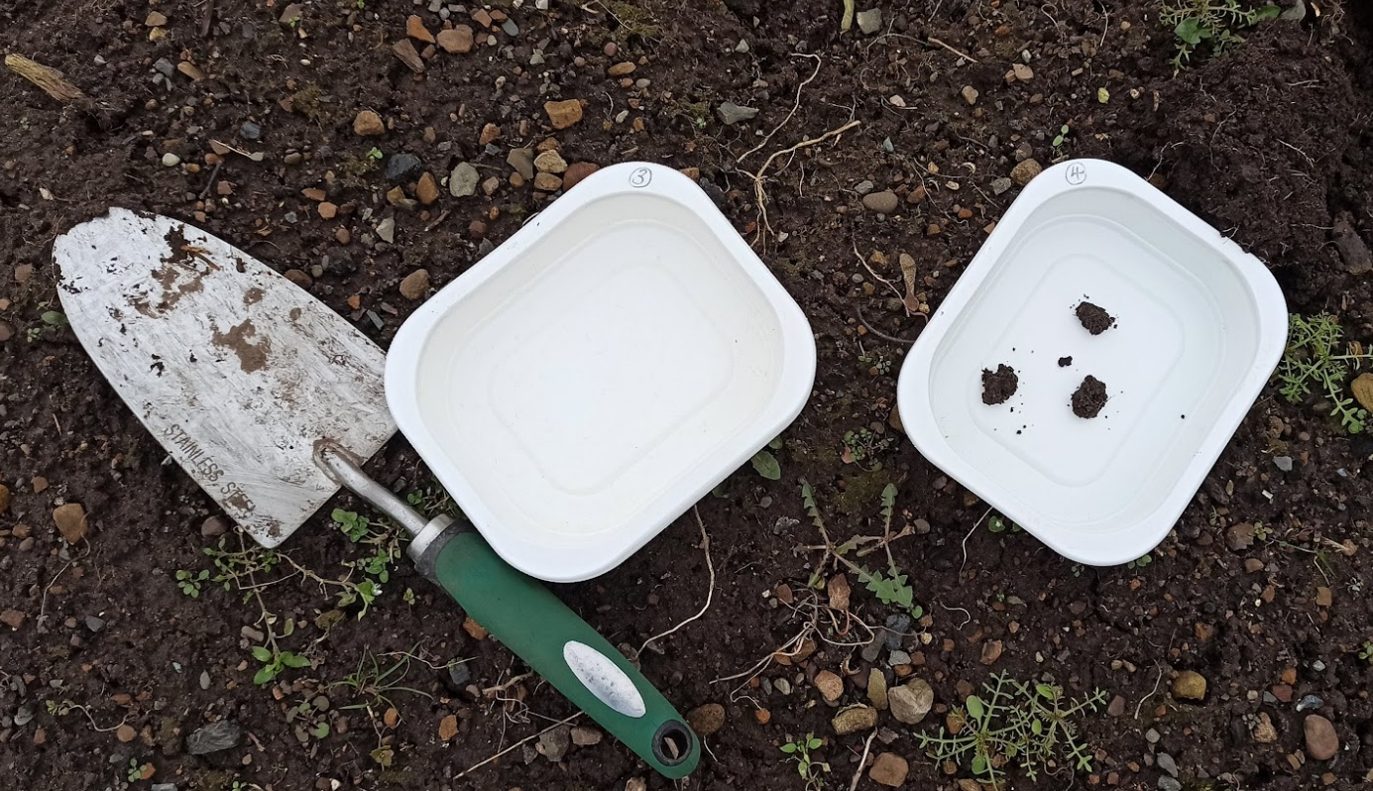

There are a few variations on slake testing protocols, but the basic principle involves immersing small (pea sized), air-dried pieces of soil in water for a short period of time and recording how fast they disintegrate. Two options for conducting slake testing on farm are listed below. Since, each test is done slightly differently, it is recommended that one method is chosen and followed each time to reduce variability in measurements. As the test assesses the strength of soil aggregates, the samples need to be handled with care. Collecting samples with a spade from the topsoil at the same time of year (autumn is preferable), when the soil is moist but not too wet or waterlogged, is recommended.

The Slakes app
The Slakes app (available for Android or iOS phone) uses air-dried (overnight or longer if very wet soil) pea sized aggregates of soil (Figure 16). Items needed; clear or white plastic dishes, tap water, and something to mount the phone over the dishes (e.g. tripod, can, jar; Figure 17). The app uses image analysis to document the disintegration of air-dried aggregates in tap water during a 10-minute period and returns an index of aggregate stability (Figure 18). Indices fall between 0.1 and 1 with a higher score indicating higher aggregate stability. The Slakes app removes the subjectivity associated with some other methods of assessing slake testing that require the operator to assign a score.
Figure 17. Simple setup of for at-home slake testing for aggregate stability using the Slakes app. Photo: Julia Cooper
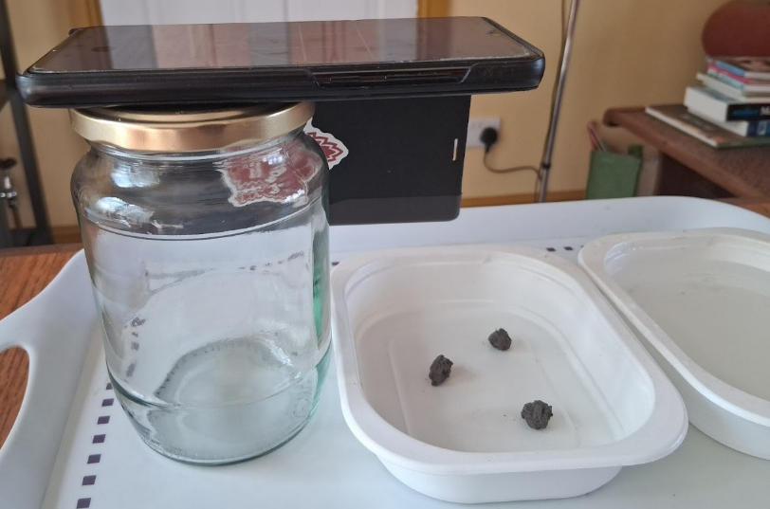
Figure 18. Example outcome from an at-home slake test using the Slakes app. Photo: Julia Cooper.
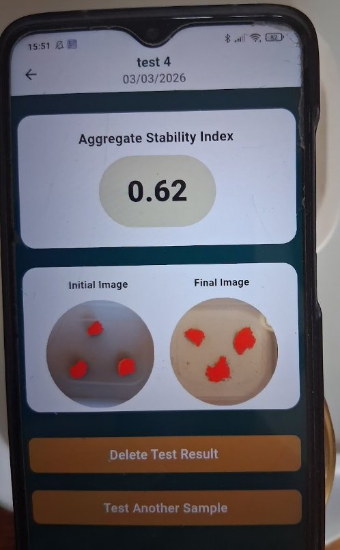

The Soil Mentor app
The Soil Mentor app (available on iOS and android) requires a typical kitchen sieve, small 1 to 3 mm sized aggregates of air-dried soil and a stopwatch/timer. Aggregates are scored between 0 and 2 after 5 minutes immersion in water depending on the amount of disintegration of the aggregates. Some degree of training is required but the phone app provides instructions and a scale (Table 22).
Table 22. Scoring systems for the slake test – adapted from Soil mentor protocol (https://soils.vidacycle.com/soil-tests/1-2-slake-0-8/) on air-dried soil.
Condition of the soil | Description | What this means
0 – Dissolves into single grains | Soil lump collapses completely; soil aggregates too unstable | Poor soil stability, lacking in soil organic matter and microbial activity
0.5 – Soil slumps to pyramid shape | Soil collapses into a cone shape of less than 2 mm grains, water cloudy | Lacking in cohesion and stability
1 – Breaks into angular pieces | Soil lumps break into large angular pieces | Loose surface and needs more microbial activity
1.5 – Stays mainly intact | Soil lump edges crumble slightly but remain largely intact | Good soil stability but could still be improved
2 – Soil lump intact | Soil lump remains intact and water is clear | Good aggregate stability, continue to monitor

How effective is aggregate stability as an early indicator to monitor changes in soil health?
A number of indicators have been recently reviewed and scored for strength of the evidence linking them to ecosystem services and as early indicators of changes in soil health. Aggregate stability was a strong candidate with a particularly high score for food, biomass and fibre production, as well as nutrient cycling (N, P and K). It also scored reasonably highly for sensitivity to management change. There is a large body of evidence linking aggregate stability to soil health which provides a high degree of confidence that it is a useful soil property to monitor, with direct links to good soil health and functioning.
Some gaps in evidence were identified, specifically relating to the sensitivity to initial soil moisture in the aggregate tested and the role of soil texture in aggregate stability, e.g. sandy soils are inherently less able to form stable aggregates due to their large particle size and pore spaces coupled with typically lower organic matter to hold aggregates together.

Recommendation
Assessing aggregate stability using the slake test is a simple, quick method that could be done on the farm to provide an early indication of a change in soil health due to a recent change in management. The costs for slake testing are minimal (the Slakes app is free and Soil mentor has an annual subscription). As a farmer-led assessment, proficiency and efficiency in sample collection and processing should build with regular use of the test. Routine slake testing on the farm focused on areas known to be “healthy” compared to areas with degraded soil structure will also build the practitioner’s confidence and skill in interpreting the results and developing understanding of what “good” looks like for slake scores within their farm’s environment.

Active carbon factsheet references
Flynn, KD, Bagnall, DK, Morgan, CLS. (2020). Evaluation of SLAKES, a smartphone application for quantifying aggregate stability, in high-clay soils. Soil Science Society of America Journal, 84(2), 345–353. https://doi.org/10.1002/saj2.20012
Trybek, M, Algarin, CAV, Grande, LHQ, Sebim, JPM, Canisares, LP, Morgan, CLS, Cerri, CEP, Cherubin, M R. (2026). Aggregate stability measurements of tropical soils under conservation agriculture using the Slakes smartphone app. Soil and Tillage Research, 257, 106984. https://doi.org/10.1016/j.still.2025.106984

Further reading
http://nmsp.cals.cornell.edu/publications/factsheets/factsheet95.pdf

AHDB is the independent, impartial public body that unlocks success in British agriculture. Funded by a levy from British farmers, growers and processors, we’re behind the invaluable research and reports, domestic marketing campaigns and global export opportunities that help British farming thrive. Together, we deliver the insights, the influence and the impact that farmers need. For more information, visit ahdb.org.uk
While the Agriculture and Horticulture Development Board seeks to ensure that the information contained within this document is accurate at the time of printing, no warranty is given in respect thereof and, to the maximum extent permitted by law, the Agriculture and Horticulture Development Board accepts no liability for loss, damage or injury howsoever caused (including that caused by negligence) or suffered directly or indirectly in relation to information and opinions contained in or omitted from this document.
© Agriculture and Horticulture Development Board 2026. All rights reserved.

The IRG consisted of representatives from: Eurofins (Arjan Reijneveld), Verdant Carbon (Dave Gollins), Hillcourt (Mechteld Blake-Kalff), Frontier (Ed Downing, Simon Griffin), ADAS (Anne Bhogal, Pete Berry), SRUC (Christine Watson)
OpenAI. (2026). ChatGPT (GPT-5.3) [Large language model]. https://chat.openai.com
Preferred methods were: POXC for active carbon, shovelomics for crop rooting, and wet sieving in a laboratory for aggregate stability; PMN is a standardised method so datasets were only recorded for this indicator if they used anaerobic incubation.
A weighted average was calculated. For active carbon and crop rooting scores, for the preferred method (POXC and shovelomics respectively) were assigned a weight of 0.6 and any alternate method was assigned a weight of 0.4. For aggregate stability, wet sieving was assigned a weight of 0.6, slake test was assigned a weight of 0.2 and any other method was assigned a weight of 0.2.
5 OpenAI. (2026). ChatGPT (GPT-5.3) [Large language model]. https://chat.openai.com
6 Ranks of criteria for each respondent were converted to weighted scores by assigning decreasing weights to ranks (1st = 6 to 6th = 1) and summing across all responses.

